Technische Universität Berlin

Faculty VII (Economics & Management)

Workgroup for Infrastructure Policy (WIP)

**An Economic Evaluation of Long-Term Financing for Nuclear Waste**

***Analysis of the German Nuclear Waste Fund KENFO***

Autor: Mahdi, Awawda

Supervisors:

Prof. Dr. Christian, von Hirschhausen

Prof. Dr.-Ing. Ronald, Plath

Berlin, 11.09.2023

**Abstract**

As Germany transitions away from nuclear energy, the challenge of managing and financing nuclear waste disposal has become increasingly urgent. The primary purpose of this thesis is to address this critical challenge by evaluating the long-term financing of nuclear waste management in Germany, specifically focusing on the state-owned fund KENFO's ability to meet future costs.

We first developed a model for an externally segregated fund to answer this complex research question by translating the economic challenges into a minimization problem from the fund's perspective. We then conducted a thorough case study that identifies the current legal framework and all relevant governmental entities involved in nuclear waste management in Germany. We performed an economic analysis across four scenarios: planned, best, medium, and worst-case.

Our analysis shows that current high-level waste disposal timelines are unrealistic and require legislative action and public discussion. Furthermore, the analysis reveals that the delays of major projects have implications for interim storage facilities, which are not designed for long-term use. Moreover, the findings indicate that KENFO lacks the financial resources to cover projected costs in all developed scenarios. This is further exacerbated by the significant financial loss KENFO incurred in the previous year, leading to a 12.2% decrease in funds compared to the prior year. According to our fund balance simulations, KENFO will run out of liquidity by the early 2070s.

Given these challenges, KENFO has two options: either increase its target return on investment, which carries inherent risks or seek federal assistance, thereby shifting the financial burden to taxpayers. We recommend that legislators conduct a novel economic evaluation, initiate public discussions to address these challenges, and eventually identify potential solutions.

**Deutsche Zusammenfassung**

Während Deutschland sich von der Kernenergie abwendet, wird die Herausforderung der Verwaltung und Finanzierung der Entsorgung von nuklearem Abfall immer dringlicher. Das Hauptziel dieser Arbeit ist es, diese kritische Herausforderung anzugehen, indem die langfristige Finanzierung der Entsorgung von nuklearem Abfall in Deutschland bewertet wird, insbesondere mit Blick auf die Fähigkeit des staatseigenen Fonds KENFO, zukünftige Kosten zu decken.

Zuerst haben wir ein Modell für einen extern segregierten Fonds entwickelt, um diese komplexe Forschungsfrage zu beantworten, indem wir die wirtschaftlichen Herausforderungen in ein Minimierungsproblem aus der Perspektive des Fonds übersetzen. Anschließend führten wir eine gründliche Fallstudie durch, die den aktuellen rechtlichen Rahmen und alle relevanten staatlichen Stellen identifiziert, die an der Entsorgung von nuklearem Abfall in Deutschland beteiligt sind. Wir haben eine wirtschaftliche Analyse über vier Szenarien durchgeführt: geplantes, bestes, mittleres und schlechtestes Szenario.

Unsere Analyse zeigt, dass die aktuellen Zeitpläne für die Entsorgung von hochradioaktivem Abfall unrealistisch sind und gesetzliche Maßnahmen und öffentliche Diskussionen erfordern. Darüber hinaus zeigt die Analyse, dass die Verzögerungen bei großen Projekten Auswirkungen auf Zwischenlager haben, die nicht für den Langzeiteinsatz ausgelegt sind. Darüber hinaus zeigen die Ergebnisse, dass KENFO nicht über die finanziellen Ressourcen verfügt, um die projizierten Kosten in allen entwickelten Szenarien zu decken. Dies wird durch den signifikanten finanziellen Verlust verschärft, den KENFO im Vorjahr erlitten hat, was zu einer Abnahme der Mittel um 12,2% im Vergleich zum Vorjahr führte. Nach unseren Simulationen der Fonds-Bilanz wird KENFO bis zu den frühen 2070er Jahren keine Liquidität mehr haben.

Angesichts dieser Herausforderungen hat KENFO zwei Möglichkeiten: Entweder erhöht es die Zielrendite, was inhärente Risiken birgt, oder es sucht föderale Unterstützung, wodurch die finanzielle Last auf die Steuerzahler verlagert wird. Wir empfehlen, dass die Gesetzgeber eine neue wirtschaftliche Bewertung durchführen, öffentliche Diskussionen initiieren, um diese Herausforderungen anzugehen, und letztlich mögliche Lösungen identifizieren.

# Directories

## Overview

Statutory declaration i

Directories iv

1 Introduction 1

2 Background 3

3 Model for External Segregated Fund 13

4 Case Study: Nuclear Waste Management in Germany 18

5 Results 37

6 Discussion 42

7 Conclusions 44

References 46

Appendix 52

## Contents

Statutory declaration i

Directories iv

Overview iv

Contents v

List of Tables vii

List of Figures viii

List of Acronyms ix

1 Introduction 1

1.1 Motivation 1

1.2 Contribution and Research Method 2

1.3 Structure of the Thesis 2

2 Background 3

2.1 Nuclear Fuel Cycle 3

2.2 Nuclear Radioactive Waste 5

2.3 Nuclear Waste Management 5

2.3.1 Nuclear Waste Categories 8

2.3.2 Volumes 8

2.3.3 Issues 9

2.4 Financing of Nuclear Waste Management 10

2.4.1 State Fund 10

2.4.2 Guarantee 10

2.4.3 Internal Segregated Fund 10

2.4.4 Internal Non-Segregated Fund 11

2.4.5 External Segregated Fund 11

2.5 Cost Estimations Methods 11

3 Model for External Segregated Fund 13

3.1 Problem Definition 13

3.2 Solving Minimization Problem 17

3.3 Assumptions & Limitations 18

4 Case Study: Nuclear Waste Management in Germany 18

4.1 Legal Framework: Site Selection Act 2017 19

4.2 Governmental Actors 20

4.2.1 The Federal Ministry for Environment, Nature Conservation, and Nuclear Safety 20

4.2.2 The Federal Office for Nuclear Waste Disposal Safety 20

4.2.3 The Waste Disposal Committee 21

4.2.4 The Federal Company for Interim Storage 21

4.2.5 The Federal Company Radioactive Waste Disposal 22

4.2.6 Fund for the Financing of Nuclear Waste Disposal 22

4.3 Planned Scenario of Nuclear Waste Management 23

4.3.1 Interim Storage Milestones 23

4.3.2 Final Disposal Milestones 24

4.3.3 Data 25

4.3.4 Funding of Nuclear Waste Management 27

4.3.5 Issue of Planned Scenario 28

4.4 Best Case Scenario 31

4.4.1 Assumptions 32

4.4.2 Long-Term Cost Projections 32

4.4.3 Long-Term Target ROI 33

4.5 Medium Case Scenario 34

4.5.1 Assumptions 34

4.5.2 Long-Term Cost Projections 34

4.5.3 Long-Term Target ROI 35

4.6 Worst Case Scenario 35

4.6.1 Assumptions 36

4.6.2 Long-Term Cost Projections 36

4.6.3 Long-Term Target ROI 36

5 Results 37

5.1 Scenarios Definition 37

5.2 Scenarios Comparison 38

6 Discussion 42

6.1 Results Validation 42

6.2 Sensitivity Analysis 42

7 Conclusions 44

References 46

Appendix 52

## List of Tables

Table ‎4‑1: Cost Projections of Nuclear Waste Management in Germany (Million EUR2014). 26

Table ‎4‑2: Ex-Post Analysis. Difference of Grant Thornton Prognosis and Actual Reported Costs of 2017-2022 (million EUR2023). 28

Table ‎4‑3: Ex-Ante Analysis. Difference of Grant Thornton Prognosis and Federal Budget Plan of 2023-2027 (million EUR2023). 29

Table ‎5‑1: Comparison of Cost Projections and Required ROI Across Different Scenarios. 39

Table ‎6‑1: Range of Two of the Independent Variables. 43

Table ‎6‑2: Sensitivity Analysis Total Variations. 43

## List of Figures

Figure ‎2‑1:Nuclear Fuel Cycle Components With Front- and Back-End Distinction. 4

Figure ‎2‑2: Illustration of Operational Tasks of Nuclear Waste Management. 6

Figure ‎2‑3: Illustration of Administrative Tasks of Nuclear Waste Management. 7

Figure ‎3‑1: Relation Between Annual Cost Projections and Fund Balance. 14

Figure ‎3‑2: Graphic Illustration of Minimizing ROI 14

Figure ‎4‑1: BGZ Facilities, Centers, and Office Locations 21

Figure ‎4‑2: Simplified Timeline for Extended Interim Storage and Final Disposal 24

Figure ‎4‑3: Ex-Ante Analysis. Difference of Grant Thornton Prognosis and Federal Budget Plan of 2023-2027 (million EUR2023) 30

Figure ‎4‑4: Milestones Timeline of Best Case Scenario 31

Figure ‎5‑1: Comparison of Cost Projections of Scenarios 40

Figure ‎5‑2: Fund Balance and Cost Projection Comparison of First and Second Scenarios for the Years 2070-2095 41

Figure ‎5‑3: Fund Balance vs. Cost Projection Across the Four Scenarios. 41

Figure ‎6‑1: Sensitivity Analysis Results. 44

## List of Acronyms

|  |  |
| --- | --- |
| **Acronym** | **Meaning** |
| AGR | Advanced Gas-cooled Reactor |
| AVR | Working Group Experimental Reactor Jülich |
| BAM | The Federal Institute for Materials Research and Testing (Germany) |
| BASE | The Federal Office for Nuclear Waste Disposal Safety (Germany) |
| BfS | The Federal Office for Radiation Protection (Germany) |
| BGE | The Federal Company for Radioactive Waste Disposal (Germany) |
| BGZ | The Federal Company for Interim Storage (Germany) |
| BMF | The Federal Ministry of Finance (Germany) |
| BMUV | The Federal Ministry for Environment, Nature Conservation, and Nuclear Safety (Germany) |
| BMWK | The Federal Ministry for Economic Affairs and Climate Protection (Germany) |
| BZA | Interim Storage Facility for Spent Nuclear Fuel in Ahaus |
| BZL | Interim Storage Facility for Spent Nuclear Fuel in Lingen |
| ECB | European Central Bank |
| EIOPA | European Insurance and Occupational Pensions Authority |
| EW | Exempt Waste |
| GKN | Nuclear power plant in Neckarwestheim |
| HAW | High-Level (Radio-)Active Waste |
| HLW | High-Level Waste |
| IAEA | International Atomic Energy Agency |
| ILW | Intermediate-Level Waste |
| KENFO | Fund for the financing of nuclear waste disposal |
| KFK | Commission to Review the Financing of the Nuclear Phaseout |
| KKK | Nuclear power plant in Krümmel |
| KKP | Nuclear power plant in Philippsburg |
| KWB | Nuclear power plant in Biblis |
| LILW | Low- and Intermediate-Level Waste |
| LLW | Low-Level Waste |
| LWR | Light Water Reactor |
| NDA | Nuclear Decommissioning Authority (U.K.) |
| NDP | National Disposal Program |
| NPP | Nuclear Power Plant |
| NS | Nuclear-Specific |
| NWF | Nuclear Waste Fund (Sweden) |
| NWM | Nuclear Waste Management |
| ROI | Return On Investment |
| StandAG | German Act on Search and Selection of a Site for a Final Disposal Site for HLW |
| STENFO | National Decommissioning and Waste Disposal Fund Organization (Switzerland) |
| TSC | Transport and Storage Container |
| VAG | German Insurance Supervision Act |
| VkENOG | Act on the Reorganization of Responsibility in Nuclear Waste Management |
| VLLW | Very Low-Level Waste |
| VSLW | Very Short-Lived Waste |
| WNA | World Nuclear Association |
| ZL | Interim Storage Facility |
| ZLN | Interim Storage Facility North |

# Introduction

In the modern energy landscape, nuclear power stands as a double-edged sword. While it offers a low-carbon alternative to fossil fuels, it begets the formidable challenge of managing nuclear waste (Clemmer et al. 2018). The intricacies of this challenge span beyond the mere technicalities of storage and disposal, delving deep into the economics of funding and long-term financial planning (Wealer and von Hirschhausen 2020). This thesis presents a comprehensive exploration of these economic intricacies, with a focus on the German nuclear waste fund, KENFO.

## Motivation

Managing nuclear waste is a complex, long-term commitment that poses significant financial, technical, and ethical challenges (Yim 2022). Like many other countries, Germany is grappling with the intricacies of safely disposing of its nuclear waste (Wimmers, Göke, et al. 2023). According to recent reports, the country aims to finalize nuclear waste disposal by 2080 (BGE 2023h). However, site selection and commissioning delays could extend this timeline by decades, thereby increasing the duration and costs associated with interim storage (ESK 2023b).

Financial projections for nuclear waste management in Germany have already shown significant discrepancies. For instance, interim storage costs were underestimated by an annual average of nearly €267 million over the last seven years (Irrek 2023). These financial miscalculations and project delays make the initial estimation of €140 billion for 2015-2099 increasingly unrealistic (Warth & Klein Grant Thornton 2015).

On July 3, 2017, the German Nuclear Waste Disposal Fund (KENFO), which is responsible for ensuring coverage of these cost projections, received a total of €24.1 billion from energy supply companies to fulfill the financial responsibilities associated with Germany's 25 nuclear power plants (KENFO 2017). With an annual average return on investment of 3.9% for such a long horizon, KENFO plans to cover the forthcoming estimated costs (Mikus 2020). However, KENFO has reported a loss of €3.1 billion, equivalent to 12.2% of the fund’s balance for 2022 (Hoh 2023; KENFO 2023c).

Given the evolving landscape, there is an urgent need for a comprehensive scientific study focused on the long-term financing of nuclear waste management in Germany. This thesis aims to:

1. Re-evaluate the cost projections for various stages of nuclear waste management, particularly interim storage and final disposal sites.
2. Assess the financial implications of project delays, especially in site selection and commissioning.
3. Develop new financial models that account for uncertainties and risks, providing a more realistic picture of the long-term financial commitments involved.
4. Offer policy recommendations to ensure adequate funds are allocated and managed efficiently to secure the long-term safe disposal of nuclear waste.

By addressing these aspects, the study would fill a significant gap in the existing literature and provide actionable insights for long-term planning and financial provisioning for nuclear waste management in Germany.

## Contribution and Research Method

From an economic perspective, the central challenge involves managing a government fund designated for long-term expenditures related to nuclear waste management. The primary aim of this external fund is to sustain an average ROI sufficient to meet all anticipated costs. This financial conundrum can be formulated mathematically as a constrained optimization problem, aiming to either (a) minimize the initial investment into the fund or (b) minimize the target ROI. Each formulation holds significant implications depending on the perspective (payer versus payee). This study focuses on the latter formulation, as the initial payment into the fund was already made in 2017 (KENFO 2017), and in-depth cost projections have been provided by the auditing firm (Warth & Klein Grant Thornton 2015). Moreover, Minimizing ROI is advantageous for KENFO. By managing its costs while aiming for a low to medium ROI, KENFO will likely face fewer financial risks. This is due to the general principle that higher average returns often come with increased market risk. (Florian, Buchner, and Kaserer 2010).

Therefore, the research questions of this study aim to address: Given its current fund balance and target ROI, will KENFO be able to cover the cost projections outlined in the most recent reports, which include delays in major nuclear waste management projects? Alternatively, will there be a need for taxpayer intervention?

A deep dive into the German context is essential to answer previous questions. This thesis comprehensively overviews Germany's legal, organizational, and operational framework for managing nuclear waste. It is based on the Site Selection Act of 2017, with a planned date for selecting a secure and suitable location for long-term nuclear waste disposal set for 2031 (BMJ 2023). This responsibility falls on the Federal Company for Radioactive Waste Disposal (BGE). However, ESK has reviewed this target and, based on BGE reports, suggests a more realistic timeframe would be between 2046 and 2068 (ESK 2023b).

The thesis outlines four scenarios to capture the economic implications: planned, best, medium, and worst-case. These offer a comprehensive view of the potential economic paths for nuclear waste management in Germany. The methods for this economic evaluation are derived from several papers (Briggs, Kunsch, and Mareschal 1990; IAEA 2007; Wealer and von Hirschhausen 2020; Warth & Klein Grant Thornton 2015).

After conducting an ex-ante analysis for each scenario, the problem is mathematically formulated as a constrained minimization problem. This can be solved using the bisection/binary search method. Finally, the simulation results are presented and compared, including the required ROI and the fund’s yearly balance for each scenario.

In essence, this thesis endeavors to bridge the chasm between nuclear waste management's technical and economic realms, offering insights, analyses, and projections that could shape policy decisions and strategic planning for years to come.

## Structure of the Thesis

The remainder of the thesis is organized as follows. First, Section ‎2 gives a theoretical background about the nuclear fuel cycle, nuclear radioactive waste, nuclear waste management, and financing of NWM. Next, Section ‎3 presents the developed model for an externally segregated fund, in which the funding problem is mathematically defined and a method to solve it. Subsequently, Section ‎4 presents a comprehensive case study on KENFO by digging into the German legal framework of governmental actors and defining four scenarios for the long-term financing of German nuclear waste. Then, the case study results are introduced in Section ‎5, comparing the four scenarios. Section ‎6 presents the result validation and sensitivity analysis. Finally, Section ‎7 highlights the main takeaways and conclusions.

# Background

This section delves into the multifaceted aspects of nuclear waste management, beginning with an overview of the nuclear fuel cycle. This work also explores the different categories of nuclear waste and the challenges associated with their management. Additionally, it discusses the financial strategies for nuclear waste management.

## Nuclear Fuel Cycle

According to the World Nuclear Association, the set of tasks generating electricity from nuclear reactions is called the nuclear fuel cycle. As illustrated in Figure ‎2‑1, this cycle begins with resource extraction, specifically uranium ore, and ends in nuclear waste management (Final storage/ disposal). To become usable in a nuclear reactor, uranium must undergo several stages, such as mining and milling, conversion, enrichment, and fuel fabrication. These collective processes are called the front-end of the nuclear fuel cycle (World Nuclear Association 2023a).

Once the uranium has been utilized for three years in a reactor for electricity generation, the spent fuel ought to be subject to additional processes that make up the back-end of the nuclear fuel cycle. More precisely, the back-end of the nuclear fuel cycle refers to the activities necessary to manage the output from nuclear reactor operation, primarily spent fuels and other radioactive wastes (Yim 2022). This term includes on-site spent fuel storage, spent fuel transport, interim external or interim internal storage, and final disposal of nuclear waste. A possible additional activity at the back-end of the nuclear cycle is reprocessing. This is the case for NPPs, where fissile material is recycled back into reactor operation (Bunn et al. 2005).

Figure ‎2‑1:Nuclear Fuel Cycle Components With Front- and Back-End Distinction.

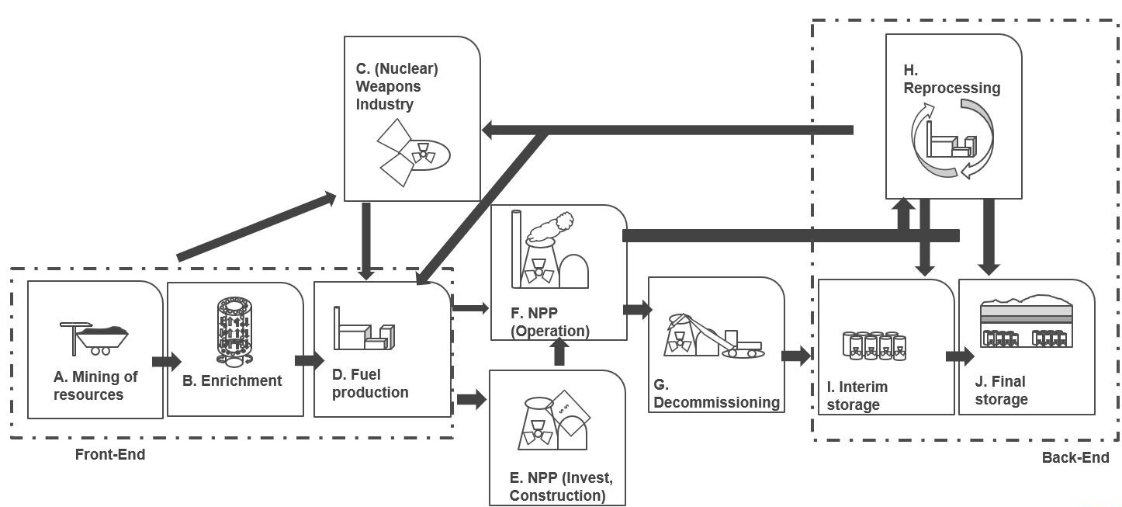

Source:(Wealer and von Hirschhausen 2020)[1]

In the context of this work, the back-end of the nuclear waste cycle is of utmost importance. Hence, we consider its three components closely. Three main objectives exist for temporarily storing produced nuclear waste (spent fuel). First, allowing the spent nuclear fuel to cool down radioactively and thermally is crucial. This is usually done in water-filled pools or dry casks, depending on the particular strategy employed at the NPP. Second, to protect staff members of a NPP and the general population from radioactive waste. Third, avoid nuclear incidents. The duration of the interim storage phase typically spreads over several years but could extend to decades, depending on the overall waste management strategy. Over time, the radioactivity decreases, making subsequent handling and transportation of the fuel safer and more manageable (National Research Council 2006).

Reprocessing, the second pillar of the nuclear back-end involves extracting valuable fissile materials from spent nuclear fuel. The reprocessed materials can be recycled back into the fuel cycle, reducing the waste volume requiring final disposal (World Nuclear Association 2020). More specifically, reprocessing does not rid spent fuel of its radioactivity; instead, it categorizes the material into groups: plutonium, uranium, and other diverse types of radioactive waste (Bunn et al. 2005). In contemporary reprocessing facilities, the widely accepted PUREX (Plutonium-Uranium Redox Extraction) method is employed to separate uranium and plutonium from spent nuclear fuel. This technique is the only one that has been commercialized and is highly effective in extracting these elements. However, reprocessing is not without its challenges. It increases the total volume of LILW and presents a proliferation risk due to plutonium extraction (IAEA 2022; Bunn et al. 2005; World Nuclear Association 2020).

The choice between a once-through, modified open, or closed fuel cycle is another significant decision within the nuclear back-end. This choice has substantial implications for waste volumes, types of waste produced, resource utilization, and overall costs (IAEA 2022).

The final disposal of nuclear waste represents the final goal of the nuclear back-end. Nonetheless, it remains one of the most challenging aspects of nuclear waste management, particularly for HLW. The most widely accepted strategy for HLW disposal involves deep geological repositories. However, despite decades of research and development, no country has yet put such a repository into operation. This reality presents a significant challenge for nuclear waste management (OECD and Nuclear Energy Agency 2003; World Nuclear Association 2023a). The economic and infrastructure implications of managing the nuclear back-end are immense. Given the long-lived nature of nuclear waste, the economic and policy decisions made today will have consequences far into the future. The associated costs are not only financial but also environmental and societal. Each aspect of the nuclear back-end, from interim storage to final disposal, necessitates substantial investment and thoughtful policy planning (Taebi and Kloosterman 2008).

## Nuclear Radioactive Waste

In nuclear safety and waste management, nuclear radioactive waste is defined as material contaminated with radionuclides at concentrations or activities exceeding the clearance levels stipulated by regulatory authorities and for which no further use is legally or operationally anticipated (IAEA 2014). Every front-end nuclear fuel cycle phase produces radioactive waste (World Nuclear Association 2021). Although waste generation occurs during the mining, milling, and fuel fabrication stages, the majority of the radioactive waste originates due to the nuclear fission process of uranium to generate electricity. If spent fuels undergo reprocessing, the total volume of HLW is significantly lowered (World Nuclear Association 2020). However, creating unstable radionuclides during this process presents a major technical hurdle for successfully reprocessing spent fuel (Banerjee et al. 2015).

Uranium extraction processes generate a range of waste materials, including dust rich in uranium, radon gas, and uranium-decay-infused liquids, typically stored in ponds. A notable waste product is the uranium mill tailings, which, when dried, are safeguarded in mounds with a protective layer of clay and soil. While various stages of uranium processing emit waste, the most pronounced radiation emissions stem from the mining and milling phases, predominantly from radon-222 gas and uranium particles. In comparison, subsequent processes, like conversion and enrichment, emit comparatively less radiation, mainly comprising uranium and its decay elements (World Nuclear Association 2023b; Yim 2022).

## Nuclear Waste Management

Nuclear waste management encompasses the entire spectrum of tasks from collecting to disposing of radioactive waste. As discussed in ‎2.1 and ‎2.2, the waste material is diverse. It is generated from different stages of the nuclear fuel cycle, such as uranium mining and milling, nuclear power plant operations, and reprocessing of spent nuclear fuel. After that, the output of these activities undergoes several operational steps before its transportation into a final disposal site. Figure ‎2‑2 shows a subset of the required operational tasks of an NWM while focusing on activities before final disposal.

Figure ‎2‑2: Illustration of Operational Tasks of Nuclear Waste Management.

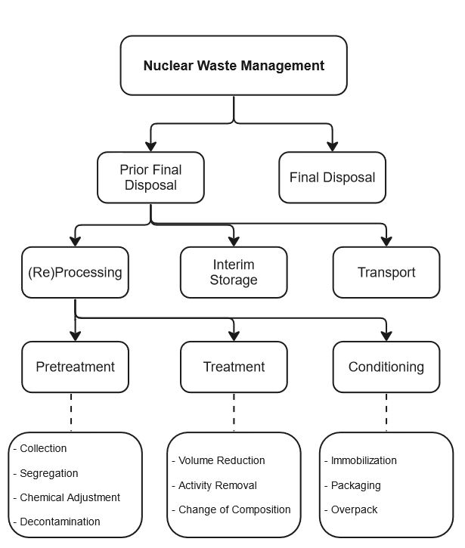

Source: Figure of (Ojovan and Steinmetz 2022). Slightly modified for this work.

While each nation holds the primary responsibility for NWM, all practices related to NWM, especially disposal, should align with the IAEA's safety principles, as detailed in (IAEA 2006). This standard aims to shield humans and the environment from radiation's adverse effects, balancing safety with operational flexibility, as outlined in the ten safety principles (IAEA 2006). These principles guide protective measures against radiation risks, ensuring the safety of both NWM activities and facilities. International bodies like the IAEA offer guidance to ensure nuclear energy technologies' safe and effective application (IAEA 2017). Nevertheless, given that NWM is a national duty, every country should establish policies for handling nuclear waste. More specifically, for nuclear energy to be sustainable and publicly accepted, it is crucial to manage the waste securely from its origin to its final disposal, which means placing it in a location without plans for future retrieval (IAEA 2009c). Hence, it is significant to view the planning of NWM from an administrative lens. Figure ‎2‑3 shows a classical overview of the development of the main milestones of NWM.

Figure ‎2‑3: Illustration of Administrative Tasks of Nuclear Waste Management.

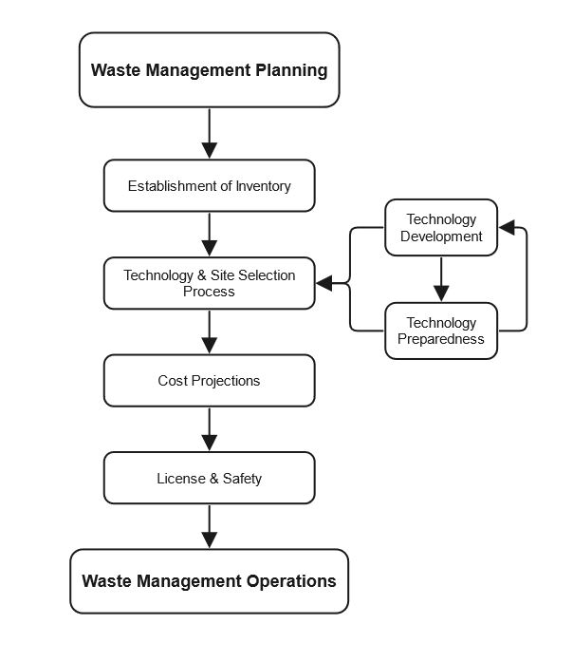

Source: Figure of (Ojovan and Steinmetz 2022). Slightly modified for this work.

The NWM begins by quantifying produced nuclear waste for each category (will be discussed in Section ‎2.3.1). Then, the NWM starts with the technology and site selection procedure. An analysis of the estimated costs of projects of decommissioning, interim storage, and final disposal must be developed. The regulator views the previously mentioned milestones and defines a legal foundation by passing laws, for instance. Finally, the actual waste management operations should take place in the shape and at the time as stated by regulatory authorities (IAEA 2009c; 2022). Various technical and administrative considerations, such as waste characteristics, waste management policies, legal requirements, political choices, societal acceptability, and natural circumstances, are considered when selecting a disposal method (Yim 2022).

Nuclear waste disposal facilities aim to minimize interactions between waste and the environment, particularly natural waterways. More precisely, several approaches can be used to accomplish this, including selecting appropriate sites (such as arid or mountainous regions), determining the depth of emplacement (near-surface, intermediate, or deep geological), utilizing water-resistant caps (such as runoff drainage layers or clay barriers), and considering long-term containment options such as borehole disposal. Preventing unintentional human incursion is critical, and the combination of possible methods, regulatory supervision, and safeguarding can help to reduce this risk (Valentin 2000; IAEA 2009c; Yim 2022; World Nuclear Association 2023a). The HLW is generally disposed of by burying it in stable geological formations, preventing any potential interaction of radioactive elements with the biosphere (Röhlig 2022).

### Nuclear Waste Categories

The International Atomic Energy Agency classified nuclear waste according to its radioactivity level and half-life into six groups (IAEA 2009c). These categories are crucial indicators for determining waste packaging, disposal facilities, and the duration for which the waste must be sequestered from human and environmental interaction. The following are simplified definitions for each waste category based on (World Nuclear Association 2022; IAEA 2009a).

1. Exempt Waste (EW): EW is low-level radioactive waste that falls below the regulatory clearance levels, posing a negligible risk. It can be disposed of in the same manner as normal industrial waste.
2. Very Low-Level Waste (VLLW): can be disposed of in surface landfills under minimal regulatory oversight. These landfills might also house other hazardous materials. This category often comprises soil and rubble with minimal radioactive activity. The presence of long-lived radionuclides in such waste is restricted.
3. Very Short-Lived Waste (VSLW): This type is stored temporarily for several years until its decay allows for removal from regulatory oversight. It can be safely disposed of upon approval by the appropriate regulatory entity. This category predominantly contains radionuclides with brief half-lives, frequently utilized in research and medical applications.
4. Low-Level Waste (LLW): LLW exceeds clearance levels but with minimal long-lived radionuclides, necessitates strong containment for several centuries, and is appropriate for disposal in engineered surface facilities. The LLW category encompasses diverse waste, including short-lived radionuclides at elevated activity levels and long-lived radionuclides at lower activity concentrations.
5. Intermediate-Level Waste[2] (ILW): This type is characterized by higher levels of radioactivity, particularly of long-lived radioisotopes. It necessitates a more advanced degree of confinement and separation compared to LLW. ILW does not generate substantial heat and is often disposed of in deep, engineered facilities.
6. High-Level Waste (HLW): This Waste produces considerable heat due to its high radioactive activity, contains substantial amounts of long-lived radionuclides, and requires special disposal facility design considerations. The preferred disposal method for such HLW is in deep geological formations, typically hundreds of meters underground.

### Volumes

Financial mechanisms for decommissioning and waste disposal are robust in most countries, and public engagement in site selection has been consistent in recent years. Accurate inventory forecasting is crucial for effectively managing radioactive waste and spent fuel. A recent report by the IAEA highlights critical insights into managing nuclear and radioactive waste (IAEA 2022). Over 80% of all solid radioactive waste is now disposed of, indicating significant progress by many countries. Moreover, The waste profile predominantly consists of VLLW and LLW, accounting for approximately 95% of the total volume. Furthermore, ILW and HLW comprise about 4% and less than 1%, respectively (IAEA 2022). From 1954 to 2016, nearly four hundred thousand tons of produced used fuel, with two-thirds currently in storage and the rest reprocessed (Besnard et al. 2019).

As of December 31, 2022, Germany's intermediate storage facilities hold over 130,000 cubic meters of LILW, most of which is prepared for final disposal. HLW is stored in Castor containers. Germany has generated approximately 15,000 tons of heavy metal in spent fuel elements, with 6,500 tons sent abroad for processing. An additional 190 tons of spent fuel elements have been generated from research reactors. Specialized containers, including high-level, heat-generating materials, have been developed for different waste types (BGE 2023a).

Experts predict that by 2080, around 10,500 tons of high-level radioactive waste will be generated, potentially requiring a repository volume of 27,000 cubic meters. Planning also anticipates around 300,000 cubic meters of LILW. Estimates for waste from the Asse mine and uranium enrichment are 220,000 and 100,000 cubic meters, respectively. The volume of LILW is expected to surge to approximately 300,000 cubic meters by 2050 due to the decommissioning of nuclear plants, with plans for disposal in the Konrad repository (BGE 2023a).

### Issues

Radioactive waste management is a worldwide challenge, and international collaboration is required to assist national initiatives. International organizations are important in advising member countries on safe, cost-effective, and ecologically safe radioactive waste disposal methods. While various governments create, modify, or execute plans, the difficulty of managing and disposing of radioactive waste extends beyond scientific and technological considerations. (Odoj and Forschungszentrum Jülich 2002). Nuclear waste management is a layered topic that must meet both scientific standards and ethical and social considerations since it is a critical component of the nuclear fuel cycle (OECD/NEA 2016).

Given the potential for long-term radioactivity, the fundamental scientific challenge is nuclear waste's safe and effective treatment and disposal. Each above-discussed nuclear waste category needs its own set of treatment and disposal procedures. For example, HLW, which is extremely radioactive, requires thousands of years of isolation, often in geological repositories. Until now, no country has commissioned a final disposal site (World Nuclear Association, 2023). The technological viability of long-term waste isolation and assessing possible environmental repercussions are important scientific research topics.

Over and above, economic problems accompany the development and implementation of waste management solutions. The cost of building and managing waste disposal facilities and anticipated future expenses connected with waste monitoring and potential remediation efforts must be considered by regulatory entities due to their substantial size (Yim, 2022). Furthermore, the problem of intergenerational equality emerges ethically, calling into question the justice of burdening future generations with managing nuclear waste and its accompanying financial liabilities. This ethical aspect emphasizes creating long-term, well-considered waste management solutions (Ojovan and Steinmetz 2022).

Moreover, public acceptability of nuclear power and waste disposal procedures is a big social concern. Society worries about safety, particularly after nuclear disasters like Chornobyl and Fukushima (Harribin 2017; Lazard 2021). Therefore, transparent decision-making procedures, clear communication of hazards and safety measures, and public engagement in choices concerning waste disposal site sites and plans are all required to increase public confidence (IAEA 2014).

Finally, nuclear waste management is a worldwide issue that may benefit from international collaboration. The International Atomic Energy Agency (IAEA) provides global standards and recommendations encouraging safe and efficient operations. Nations must simultaneously account for their particular settings when implementing nuclear waste management policies (OECD/NEA 2016).

## Financing of Nuclear Waste Management

The IAEA defines several methods for financing of NWM. Various distinct but potentially complementary financial strategies can be implemented to manage and decommission radioactive waste. Various international instances illustrate how these schemes have been applied and their effectiveness (IAEA 2007). In the following, we briefly introduce these strategies.

### State Fund

State funds, or the public budget, are designated for funding the government's NWM activities. In the initial phases of establishing a waste management system, especially when no dedicated funds are available, government financing often serves as the main fiscal resource (IAEA 2007). This approach is commonly employed when the state takes on obligations for "historic or orphan wastes." For example, the UK's NDA, entirely financed by the government, oversees the decommissioning of legacy and AGR fleets owned by EDF Energy (NDA 2021; Wimmers, Bärenbold, et al. 2023). Likewise, in the former East Germany, the state-owned EWN company, supported by federal funding, manages decommissioning tasks at the former Greifswald and Rheinsberg sites (Besnard et al. 2019; EWN 2021).

### Guarantee

Also referred to as the surety method. As an alternative to directly exploiting state budget resources, state guarantees can enable NWM organizations to secure financial resources via bank loans or other instruments. This approach is often more relevant in the early phases of repository development and can benefit the state budget as it does not deplete state funds directly (IAEA 2007). However, the timing and extent of state guarantees may not always align with NWM organization’s needs. In the U.S., licensees have multiple options to meet monetary guarantee stipulations, such as surety bonds, letters of credit, and parent company guarantees. Almost one-third of licensees use these approaches, solely or hybrid, after undergoing financial vetting by the Nuclear Regulatory Commission (Moriarty 2022; Wimmers, Bärenbold, et al. 2023).

### Internal Segregated Fund

In this model, license holders contribute to a self-administered fund designated solely for decommissioning and waste disposal activities. This fund is kept separate from the company's other assets and business interests, providing enhanced protection against insolvency and greater transparency (Irrek 2023; OECD/NEA 2016). The money can either be tracked independently or kept in a third-party deposit account., such as a commercial bank or treasury. This arrangement restricts the availability of the funds and streamlines monitoring, guaranteeing they are utilized solely for their designated function (OECD/NEA 2021). France employs this approach (Schneider et al. 2018).

### Internal Non-Segregated Fund

Operators collect and manage funds as internal reserves without separating them from other business assets or interests in the internal non-segregated funding model. Regulatory monitoring is conducted ex-post, which raises concerns about the funds' adequacy, transparency, and availability (OECD/NEA 2021). While this approach was once popular, especially among almost half of the NEA nations in the initial years of the 21st century, it has declined in usage due to growing concerns about liquidity and fund sufficiency (OECD/NEA 2021; 2016). Fund liquidity and adequacy concerns have contributed to the decline in this approach's popularity (OECD/NEA 2016). Utilities in west Germany continue using this funding model (Schneider et al. 2018).

### External Segregated Fund

In this model, funds are gathered and managed by a third party, with oversight provided by a specialized regulator. This configuration fosters increased openness, heightened safeguards against financial failure, and bolstered public trust. Licensees contribute to these segregated funds, entirely separate from their other business assets (OECD/NEA 2021). Once contributions are made, licensees relinquish control over these funds (Schneider et al. 2018). In countries like Switzerland and Sweden, centralized organizations like STENFO and the NWF manage these funds for decommissioning and waste disposal. In Switzerland, STENFO calculates fees based on cost-estimation studies conducted every five years and restricts reimbursements until all nuclear plants are radiologically decommissioned (STENFO 2021; UVEK 2019). Sweden's NWF manages a collection of fees and asset pool and informs other governmental authorities (Kärnavfallsfonden 2020). Operators of nuclear power plants in Sweden are also required to offer security for upcoming fees and unexpected occurrences (Swedish National Debt Office 2022; Stralsakerhetsmyndigheten 2015). This comprehensive approach ensures the funds are exclusively used for their intended decommissioning and waste disposal purposes.

## Cost Estimations Methods

Various strategies and methodologies have been explored to address the intricate issue of NWM financing. The report "Costing of Spent Nuclear Fuel Storage" (IAEA 2009b) provides a comprehensive guide for understanding the economic considerations and cost estimations associated with spent fuel storage, particularly in light of delays in geological disposal and diminished reprocessing activities. Adding to this, multi-criteria analysis methods like PROMETHEE and GAIA are introduced as effective tools for navigating the complexity of NWM (Briggs, Kunsch, and Mareschal 1990). Furthermore, the paper (OECD 2010) provides a global survey of cost components, estimation techniques, and documentation obligations related to decommissioning. The decommissioning of NPPs is elaborated in detail in (OECD/NEA 2016).

Accurate cost estimation is a cornerstone of any radioactive waste disposal program. IAEA outlines three primary methods for cost estimation in radioactive waste disposal: the Analogy Method, the Engineering Buildup Method, and the Parametric Method (IAEA 2007). Each method has its merits and limitations, and the choice of method often depends on the stage of the disposal agenda and the data availability. The following is a small introduction and comparison of these three cost projection schemes based on (IAEA 2007).

**Analogy Method**

This method is generally employed in the early stages of disposal programs when detailed specifications are not yet available. This method leverages cost data from similar, previously executed programs and adjusts for differences such as scale, complexity, and material requirements. While the Analogy Method provides a quick and straightforward way to generate initial cost estimates, its accuracy is often limited due to the high variability in disposal costs. This method is less reliable for detailed budget planning but is a useful starting point.

**Engineering Buildup Method**

Also known as the Bottom-up Method, the Engineering Buildup Method becomes increasingly relevant as the disposal plan matures. It involves breaking down the NWM program into specific components, often laid out in a Work Breakdown Structure (WBS). The costs of these individual components are then estimated, and their summation provides an overall cost estimate. As the disposal plan evolves, the WBS becomes more detailed, enhancing the cost estimate's accuracy. This method is particularly useful for complex, long-term projects where each component needs to be scrutinized for cost optimization.

**Parametric Method**

This is most applicable when a large dataset of historical costs is available. It establishes a statistical relationship between various parameters of the disposal plan and the associated costs. While this method can offer a high degree of accuracy, its applicability is often limited in the context of radioactive waste disposal. This is because completed disposal programs are scarce, and there is significant variability in their design and execution.

Choosing the appropriate costing method is crucial for successfully planning and implementing a radioactive waste disposal plan. While the Analogy Method is suitable for preliminary estimates, the Engineering Buildup Method offers a more detailed and accurate approach for mature NWM organizations. The Parametric Method, although precise, is less commonly applicable due to the scarcity of comprehensive historical data. Therefore, a hybrid approach that combines elements of these methods may often be the most pragmatic solution for cost projections of radioactive waste disposal. Furthermore, the following papers and reports consider other approaches to financing NWM. In this, multi-criteria analysis methods like PROMETHEE and GAIA are introduced as effective tools for navigating the complexity of NWM. Moreover, the papers (OECD 2010) provide a global survey of cost components, estimation techniques, and documentation obligations for decommissioning. In (OECD/NEA 2016), the decommissioning of NPP is introduced in detail. In (IAEA 2009b), the report provides comprehensive information on spent fuel storage costs, including updated cost analysis methods and examples.

# Model for External Segregated Fund

## Problem Definition

From an economic standpoint, the following challenge discusses managing an external segregated fund specifically to finance long-term nuclear waste management expenses in a particular country. Based on the Engineering Buildup Method discussed in ‎2.5, the fund is designed to cover all (or a subset of) costs related to the management of nuclear waste, encompassing every (or a subset of) project(s) from initiation to completion within the country. Nuclear waste management projects' whereabouts and external funds are typically based on a legal foundation. Several comprehensive economic studies must be conducted to determine cost projections, e.g., ex-ante analysis, risk assessments, inflation rates, regulatory compliance, technological advancements, labor costs, supply chain dynamics, insurance/ liability, market dynamics, and competition (IAEA 2009b; 2009c). Once the state has defined specific cost projections, the initial capital investment to create the external segregated fund is determined to cover forthcoming costs by achieving a yearly target ROI. Simultaneously, the fund must set up its investment portfolio to obey state regulations while ensuring previously estimated costs are covered under a predefined risk. Furthermore, the fund requires making several assumptions, such as target ROI, inflation rate, risk management, etc.

More specifically, one significant task of an external fund is to identify the required yearly average ROI (Target ROI) that ensures sufficient liquidity to cover all future costs, given an initial balance of the fund and the total of specific cost projections for each year. This problem can be formulated mathematically as a ***constrained optimization problem***, seeking to minimize the initial investment into the fund for a given target ROI and cost projections. Such a formulation of the problem might be important from the perspective of regulatory entities, which plan to determine the least possible yet feasible initial amount to invest into the external fund. Alternatively, from the external fund’s perspective. After pumping the initial investment into the fund, one can minimize the average yearly target ROI for a given initial fund balance and cost projections. In the context of this work, we focus on the latter challenge since this fits the conducted case study in Section ‎4 and the general principle that higher average returns often come with increased market risk (Florian, Buchner, and Kaserer 2010).

The graph illustrates the mathematical problem by plotting the relation between cost estimations and the required fund balance. In year t=0, the initial fund is paid into the external segregated fund. Moreover, the yearly estimated costs are due from t=1 until the end of the last project, i.e., t=T. The expressed Fund Balance function (marked in red) must, therefore, be greater than the Cost Projections function (marked in blue) for the timeframe [ t=1, …, t=T ].

Figure ‎3‑1: Relation Between Annual Cost Projections and Fund Balance.

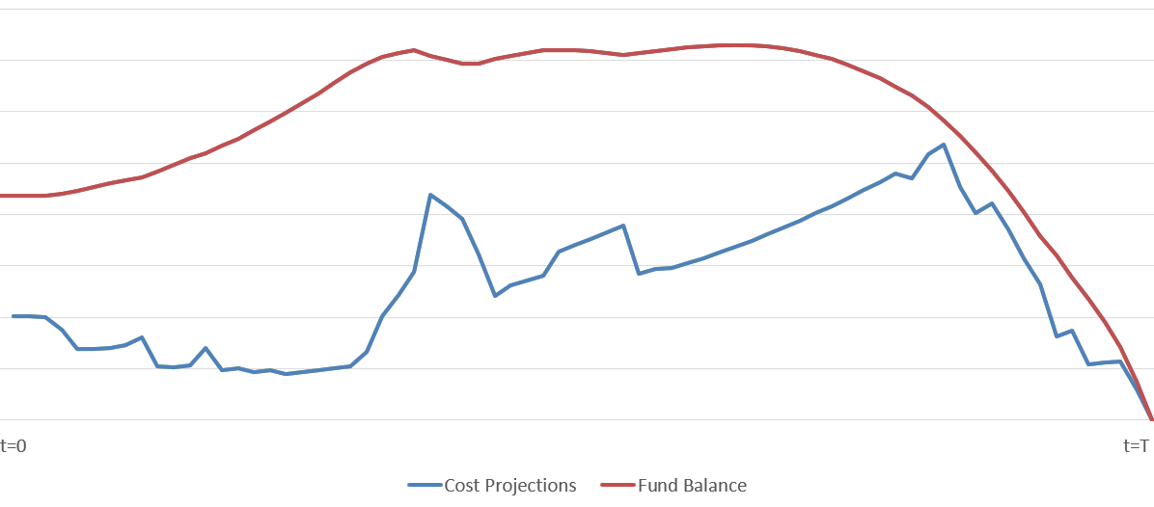

Source: Own depiction based on ex-ante analysis and fund balance simulation results.

Therefore, the challenge from the fund’s management perspective is to ensure a stable long-term portfolio performance. The necessity of finding the minimal feasible ROI is based on risk management principles, i.e., a higher target ROI is naturally accompanied by greater risk, and conversely, a lower target ROI will result in lower financial risks (Florian, Buchner, and Kaserer 2010). Therefore, the fund should aim for the lowest possible ROI average. Hence, defining the presented predicament as a mathematical minimizing problem that aims to find the least possible average ROI that satisfies several constraints. The following graph demonstrates how the Fund Balance function should be minimized.

Figure ‎3‑2: Graphic Illustration of Minimizing ROI

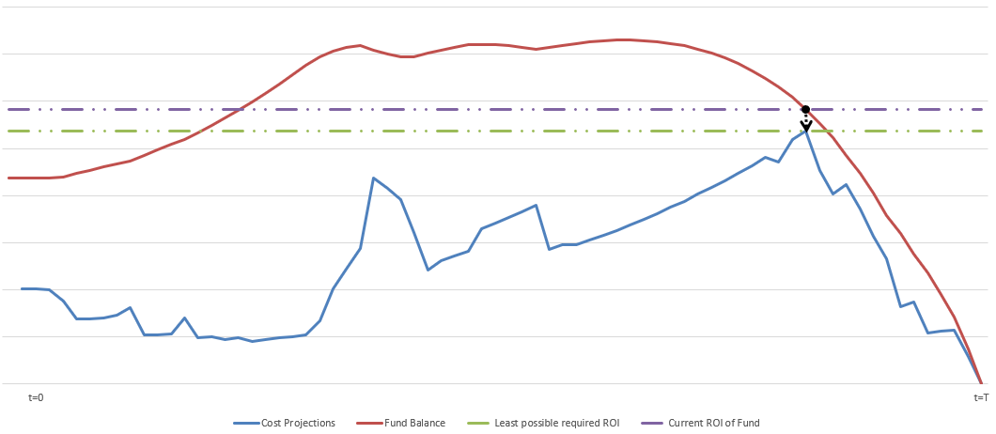

Source: Own depiction based on ex-ante analysis and fund balance simulation results.

We define an optimization problem with constraints. The following mathematical definition presumes the presence of both cost projections and the initial required fund balance, with an unknown target ROI.

**Objective Function:**

Minimize ***ROI***

( 1 )

subject to

*Fund Balance t-1 + ROI t ≥ Costs t*

( 2 )

*with*

*ROI*: *t*

( 3 )

*Fund Balance t* : *Fund Balance t-1 × (1 + ROI) - Costs t*

( 4 )

*ROI t* :

( 5 )

*Costs t* ∈ Costs Projections

*Costs* Projections *:* { *Costs t=1 ,* *Costs t=2 ,* *… ,* *Costs t=T* }

*ROI*: The Return on Investment expressed as a percentage. The average rate of return must be achieved each year to cover the projected costs.

*Fund Balance t*: The fund's balance at the year’s end.

*Fund Balance t =* 0: The initial amount pumped into the fund.

$\text{Fund Balance} \text{t-1}$: The fund's balance at the end of the previous year t-1.

$\text{Costs }\text{t }$: The projected cost for nuclear waste management in year t.

Depending on the country’s and the external segregated fund’s regulation, the external segregated fund might have defrayed costs of the whole process, i.e., projects relating to nuclear waste management such as a subset of those. Hence, subdividing the cost projection variable by formulating these into binary variables is very important.

*Costs t* : ts+ ts + ts

(6)

*with*

*F ts*: final disposal cost projections in a defined site for a particular calendar year.

*I ts* Interim Storage Cost projections in a defined site for a particular calendar year.

*D ts*: Decommissioning and Dismantling Costs in a defined site for a particular calendar year.

t  ∈ [t=1, t=2, … , t=T], s  ∈ [site 1, site 2, … , site n], i, j, k  ∈ [0,1], n, t ∈ ℕ

T: The year in which the last project is finished.

s: the set of all considered sites of nuclear waste management projects.

i,j,k: binary variable. Substitute one if the cost component is to be covered by the fund; otherwise, zero.

*F t* :Capital ts + Operation ts + Transport ts + Disposal ts + Regulatory ts +Misc. ts

(7)

*I t* :Capital ts + Operation ts + Transport ts + Regulatory ts +Misc. ts

(8)

*D t* : Decontamination and Demolition ts + Transportation ts + Site Restoration ts + Safeguarding + Misc. ts

(5)

*with*

t  ∈ [t=1, t=2, … , t=T], s  ∈ [site 1, site 2, … , site n], i, j, k  ∈ [0,1], n, t ∈ ℕ

T: The year in which the last project is finished.

s: the set of all considered sites of nuclear waste management projects.

Capital ***ts*** = Costs associated with building the facility, including land, construction materials, equipment, and labor.

Operation ***ts*** = Operation and maintenance costs of the storage facilities and costs associated with environmental monitoring and surveillance of the storage facility and the surrounding area.

Transport ***ts*** = Costs associated with transporting the waste from the point of generation to the storage facility. This includes the cost of packaging and transporting the waste and any necessary infrastructure improvements to support transportation.

Disposal ***ts*** = Costs associated with the final disposal of the waste. This includes the cost of preparing the waste for disposal, the cost of disposal containers, and the cost of placing the waste in the final repository.

Regulatory ***ts*** = Costs associated with complying with regulatory requirements related to the storage and disposal of nuclear waste. This includes the cost of obtaining permits, monitoring and reporting data, and maintaining compliance with environmental and safety regulations.

Decontamination and Demolition ***ts*** = This can involve several methods such as chemical or mechanical removal, in situ decontamination (like heating), or simply letting the radioactive material decay over time. Demolition, however, is safely tearing down the structures at the nuclear facility once they have been sufficiently decontaminated.

Site Restoration ts = After the nuclear facility has been decommissioned and demolished, the site often needs to be restored. This can involve various activities, including removing any remaining structures, remediation of contaminated soil or groundwater, and regrading or replanting to restore the site to a safe and usable condition.

Safeguarding ***is*** = Throughout the decommissioning and dismantling process; ongoing security measures are needed to protect against theft or sabotage of radioactive materials. Safeguarding also refers to the measures taken to ensure the safety of workers and the public during this process. It could include personal protective equipment, safety training, air and water monitoring, emergency response planning, and other safety measures.

Misc. ***ts*** = This could contain different types of special costs varying from insurance, security, research, and development costs for NWM tasks.

## Solving Minimization Problem

The bisection method, also known as the binary search method, is a common approach for identifying a target value within a predefined set range. To determine the smallest possible target ROI for a given initial balance amount and cost projections of nuclear waste management, the method can be utilized to solve the minimization problem introduced previously. First, we define a lower and an upper bound, encapsulating the expected ROI range. These bounds' differences should not exceed a pre-set tolerance, ensuring solution accuracy.

The following pseudo-code describes the proposed method.

|  |  |  |  |
| --- | --- | --- | --- |
| **Algorithm 1: Algorithm to Calculate Smallest Possible ROI** | | | |
|  | **input:** | | |
|  |  | an array of double values ***costs*** representing annual cost projections, | |
|  |  | a double value ***initialBalance*** representing the initial fund balance | |
|  | **output**: | | |
|  |  | a double value *targetROI* representing the resulting ROI that ensures cost coverage over a given period | |
| **1** | **begin** | | |
| **2** | **initialization of variables:** | | |
| **3** |  | ***lowerBound*** := 0; | |
| **4** |  | ***upperBound*** := 100; | |
| **5** |  | ***tolerance*** := 0.000000000001; | |
| **6** | ***while*** (***upperBound*** - ***lowerBound***) > ***tolerance*** do | | |
| **7** | **begin** | | |
| **8** |  | ***assumedROI*** := (upperBound + lowerBound) / 2; | |
| **9** |  | ***balance*** := initialBalance; | |
| **10** |  | ***for*** ***cost*** in ***costs,*** do | |
| **11** |  | **begin** | |
| **12** |  |  | ***balance*** := ***balance*** * (1 + ***assumedROI*** / 100) - ***cost***; |
| **13** |  |  | ***if*** ***balance*** < 0 ***then*** |
| **14** |  |  | ***break***; |
| **15** |  | **end**; |  |
| **17** |  | ***if*** ***balance*** < 0 ***then*** | |
| **18** |  | ***lowerBound*** := ***assumedROI*** | |
| **19** |  | ***else*** | |
| **20** |  | ***upperBound*** := ***assumedROI***; | |
| **21** | **end**; | | |
| **22** | ***return*** **(*upperBound* + *lowerBound****)*/ 2; | | |
| **23** | **end*;*** | | |

During each iteration, the midpoint of the current bounds, termed “assumedROI” is calculated and tested. The fund's balance is projected over time using this ROI, adjusting for anticipated costs. If, at any point, the balance goes negative, it indicates the assumed ROI is too low. Conversely, if the fund remains solvent, a lower ROI might suffice. Depending on the outcome, the bounds are adjusted, and the process repeats.

By consistently narrowing the solution space (lowerBound and upperBound), the binary search method ensures a rapid and efficient convergence to the optimal ROI, providing a streamlined solution to the proposed complex financial problem.

## Assumptions & Limitations

First, the proposed model assumes that the funding organization has enough liquidity (Funding t-1) to cover the estimated costs of NWM. However, it is important to note that the costs of nuclear waste management can be substantial and vary depending on a range of factors, including inflation rate cost increase of any of the components discussed in Section ‎3.1. Therefore, the assumption that cost projection will be similar to the costs post commissioning final disposal site may not be accurate, yet necessary to make.

Second, the proposed model assumes that a positive generated ROI plus the fund balance will sufficiently cover the annual costs of nuclear waste management. This assumes that the ROI generated by the funding organization will be stable over time and that the fund balance must be greater than annual costs over the project’s timeline. However, it is important to note that the ROI generated by the funding organization may be subject to volatility and uncertainty. Factors such as changes in interest rates, market conditions, government policies, wars, and catastrophes can all impact the ROI generated by the funding organization.

The costs associated with these phases can vary depending on the nature and amount of waste, the regulatory environment, and the availability of suitable storage facilities (OECD 2010; IAEA 2009b; OECD/NEA 2016).

# Case Study: Nuclear Waste Management in Germany

The following section provides an overview of Germany's legal, organizational, and operational framework for managing nuclear waste. It outlines the Site Selection Act of 2017, which defines selecting a safe and suitable location for long-term nuclear waste disposal within the country (BMJ 2023). Moreover, the section introduces primary governmental entities responsible for interim storage and final disposal of radioactive waste. Additionally, the fund for financing nuclear waste disposal (KENFO) will be introduced. Furthermore, Germany’s NWM plan is presented[3]. According to this, the target of completing HLW's final disposal is set for 2080. However, based on official reports and data from governmental entities, we argue why this objective will certainly not be the case. Based thereon, we identify and define an economic problem regarding German funding of NWM. The defined economic problem explores adjusted timelines, major milestones, previously estimated cost projections, and their necessary funding volumes to cover the process of NWM. Lastly, we emphasize the necessity of conducting an economic evaluation of long-term funding of German nuclear waste management regarding the current knowledge provided by governmental entities (ESK 2023b; BGE 2023h; KENFO 2023c). Therefore, we define three possible scenarios (best, medium, and worst-case scenarios). In each of these, the timelines of milestones and project objectives of the Site Selection Act are being adapted to recent reports to evaluate their monetary consequences on KENFO and, eventually, tax-payers (BMJ 2023).

## Legal Framework: Site Selection Act 2017

Under regulations set forth by the Site Selection Act, guidelines were established to conduct a robust procedure for the site selection of a long-term nuclear waste repository within Germany. The legislation demands a site selection process characterized by inclusivity, scientific rigor, transparency, introspection, and adaptability (BMJ 2023).

It stipulates that the process's ultimate goal is to determine the safest possible location within the country’s borders for disposing of HAW. This location is characterized as one that can provide the highest level of safety for the long-term safeguarding of people and the environment from the detrimental impacts of ionizing radiation and other negative consequences of waste. This level of safety is to be maintained for ***one million years*** and should prevent the imposition of excessive burdens and obligations on future generations. To align with this objective, the law asserts that Germany will refrain from entering into agreements with other countries that would enable the transfer of radioactive waste for disposal outside of Germany, in line with Council Directive 2011/70/EURATOM issued on July 19, 2011 (BASE 2015).

The legislation specifies rock salt, clay rock, and crystalline rock as the primary geological materials suitable for storing HAW in Germany. It recommends that the selected site ideally possess deep geological formations appropriate for constructing a final disposal site for permanent closure. The legislation further proposes that there should be provision for the retrievability of the waste during the disposal site's operational phase and the possibility of recovery for 500 years following the site's planned closure. Per the guidelines in §§ 12 ff., the site selection process is inherently reversible. A key target is set for the year 2031 to finalize the selection of the site. The StandAG legislation further allows the depositing of LILW at the chosen site. However, this is conditional upon the site demonstrating the same high level of safety as would be required for the exclusive disposal of high-level radioactive waste.

## Governmental Actors

According to the act on the reorganization of responsibility in nuclear waste management, short VkENOG, the complete responsibility for both interim storage and final disposal of radioactive waste has been transferred to the state, whereas the responsibility of decommissioning and dismantling NPPs is still of the operators (BMJ 2017b). Since then, several government entities have been managing radioactive waste in Germany. In addition to these governmental organizations, other entities, such as the National Monitoring Committee (NBG), which consists of experts and randomly selected citizens, participate in the site selection procedure. The following briefly introduces these state entities, their objectives, and tasks.

### The Federal Ministry for Environment, Nature Conservation, and Nuclear Safety

The Federal Ministry for the Environment, Nature Conservation, Nuclear Safety, and Consumer Protection (BMUV) holds a multifaceted role in the government, with responsibilities encompassing the protection of the public from environmental toxins and radiation, promoting the wise and efficient use of raw materials, and advancing climate action. This includes a commitment to using natural resources to safeguard the diversity of animal and plant species and their habitats, a mission the ministry has pursued for over 30 years (BMUV 2021).

Additionally, the BMUV directly supervises aspects of nuclear safety and radiation shielding, encompassing the authorization processes for Nuclear Power Plants (NPPs) and associated establishments. Governmental authorities carry out these procedures in the federal states (BMUV 2023). BASE and BfS are subordinate authorities to the BMUV. There are several advisory bodies of BMUV, including the Reactor Safety Commission (RSK) for nuclear safety matters, the Commission on Radiological Protection (SSK) for radiation issues, and the Nuclear Waste Management Commission (ESK) for concerns related to nuclear waste management (BMUV 2023).

### The Federal Office for Nuclear Waste Disposal Safety

The Federal Office for Nuclear Waste Disposal Safety operates under BMUV. BASE is critical in managing and disposing of German nuclear waste. It oversees the site selection process for HAW disposal in compliance with the Site Selection Act (BMJ 2023), coordinating public involvement and updating the public on the search's progress.

BASE also supervises administrative procedures concerning mining, water, and nuclear laws related to radioactive waste disposal (BASE 2022d). It ensures compliance with safety regulations across all phases of nuclear waste repositories: construction, operation, and decommissioning. It monitors the Morsleben final repository, the Asse II mine shaft, and the Konrad shaft (BASE 2022c). Moreover, BASE reviews permit applications for interim storage facilities and nuclear fuel transports, including spent fuel for mainly large-scale radioactive sources (BASE 2022c). Since the decommissioning of Germany's last nuclear power plants in 2023, BASE has ensured maintaining safety standards during the decommissioning of NPPs (BASE 2023). Last but not least, experts of this organization are involved in national and international safety committees, where they provide consulting to the German federal government.

### The Waste Disposal Committee

Established in 2008 under BMUV, the ESK provides specialized advice on nuclear safety matters (ESK 2023a). Supported by a secretariat within the BASE, ESK's advisory role can be solicited by BMUV or taken up independently. The committee offers scientific and technical recommendations without legal or political evaluations, and its conclusions are thoroughly reasoned (ESK 2023a). The ESK exemplifies Germany's commitment to transparent and responsible nuclear safety governance, as stated in the Site Selection Act (BMJ 2023).

### The Federal Company for Interim Storage

The Federal Company for Interim Storage (BGZ) was established to ensure the safe and reliable interim storage of radioactive waste (BGZ 2023c). BGZ is an independent entity organized under a private legal form, initially financed through the federal budget, for which the government will get reimbursed through KENFO (BGZ 2023b). Since 2020, BGZ has operated twelve storage facilities for LILW, as well as fourteen storage facilities for HLW, at the NPP sites that were transferred under BGZ's control (BGZ 2023c; 2023b). As seen in Figure ‎4‑1, these facilities are presented along with the two offices on Germany’s map. This strengthens BGZ's position in being fully accountable for the temporary holding of all radioactive byproducts originating from energy providers.

Figure ‎4‑1: BGZ Facilities, Centers, and Office Locations

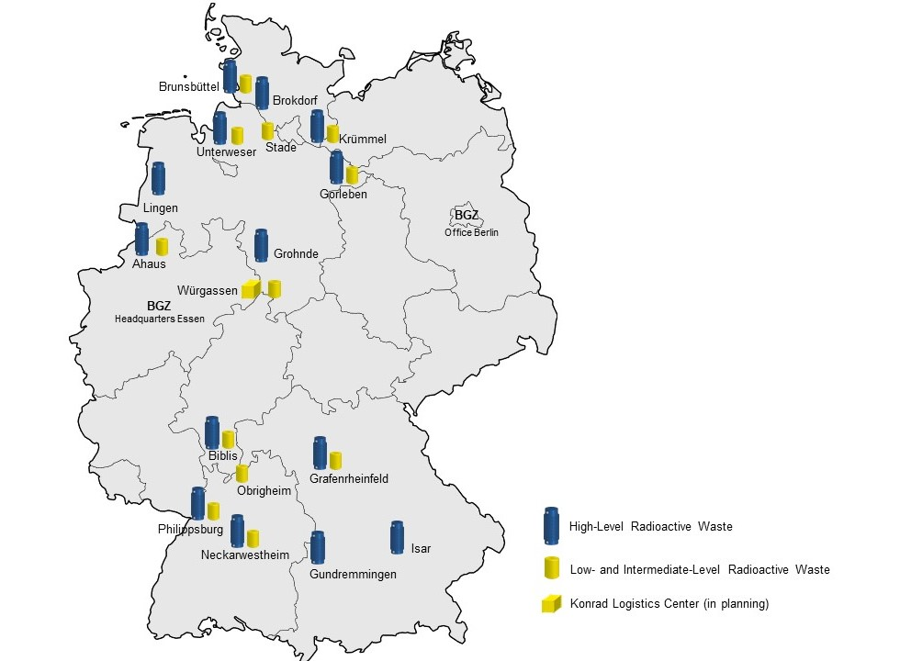

Source: Figure of (BGZ 2023c). Translated and slightly modified for this work.

### The Federal Company Radioactive Waste Disposal

The Federal Company for Radioactive Waste Disposal (BGE) is a state-owned company founded in July 2016, which is responsible for the disposal of radioactive waste in Germany (BGE 2023f). Since April 2017, BGE has been operating the final repository projects Konrad, Morsleben, the Asse II shaft facility, and the Gorleben mine (BGE 2023f). BGE is also tasked with the search for a final repository of HLW. As stated in the Site Selection Act (BMJ 2023) and discussed in Section ‎4.1, the disposal site must guarantee maximum safety for one million years.

BGE's specific tasks include the construction and operation of final disposal sites after the site selection phase is done, the checking and control of filled containers, the retrieval of waste from Asse II, the erection and operation of the Konrad final disposal site, the safe operation of the Morsleben final disposal site including its future shutdown, and the shutdown and backfilling of the Gorleben mine (BGE 2023e). These responsibilities have been transferred to the BGE by the federal government, which continues to supervise the company with the help of governmental entities, e.g., BASE (BGE 2023e).

### Fund for the Financing of Nuclear Waste Disposal

In the intricate domain of long-term funding for nuclear waste management in Germany, the Nuclear Waste Management Fund (KENFO) plays a critical role. Operating with a workforce of approximately 30 specialists, nearly 50% are directly engaged in investment and risk management (KENFO 2023b). The legal framework governing KENFO's investment activities is dictated by the German legislation VAG, which focuses on the triad of security, profitability, and liquidity while maintaining a diversified investment portfolio (BMJ 2018).

Central to KENFO's investment is the concept of Strategic Asset Allocation (SAA). The SAA is meticulously designed to ensure that the fund retains adequate capital reserves to meet the projected costs of nuclear waste disposal over an 80-year horizon (KENFO 2023b). This long-term financial planning is crucial for the sustainability of nuclear waste management efforts in Germany. Furthermore, the long-term ROI target of KENFO is 3.90% (Mikus 2020).

Regarding investment categories, KENFO's portfolio is bifurcated into liquid and illiquid assets. Liquid assets, traded on organized markets, contrast with illiquid assets encompassing a range of investment vehicles such as corporate investments, loans, and other non-tradable financial instruments (Mikus 2020; KENFO 2023b). KENFO's portfolio is divers. Approximately 35% of the portfolio is allocated to exchange-traded equities, employing active allocation strategies to optimize returns. Risky bonds, which include corporate and emerging market government bonds, constitute 25% of the portfolio, extending KENFO's investment footprint to over 90 countries globally. Low-risk government bonds issued by industrialized nations and development banks make up 10% of the investment pool. The remaining 30% is invested in illiquid assets, including but not limited to venture capital, personal loans, structural developments, and property investments. These illiquid investments offer KENFO the opportunity to explore returns beyond traditional capital markets, thereby enriching the portfolio's risk-return profile (KENFO 2023b; 2023c; Mikus 2020).

## Planned Scenario of Nuclear Waste Management

According to the Act Reorganizing Responsibility for Nuclear Waste Management, NPP operators must decommission their NPPs (BMJ 2017b). On the other hand, the German government assigned responsibility to state-owned companies (BGE and BGZ) for planning and executing final disposal and interim storage tasks, respectively (BMJ 2017b). The following two subsections describe their operational tasks and discuss major interim storage and final disposal project milestones separately.

### Interim Storage Milestones

In this subsection, the milestones' description is according to a recent report of ESK based on the Site Selection Act (BMJ 2023; ESK 2023b). Figure ‎4‑2 below illustrates these milestones for both state-owned companies (BGZ and BGE). As for the interim storage, after shutting down the last NPPs in Germany, the BGZ starts by conducting a thorough investigation to answer major questions, e.g., how the aging behavior of containers and inventories can be obtained before the last transport and storage casks (TLB) are sealed (BASE 2019a; 2022d; 2022b). In 2026, the extended interim storage approval procedure ought to be started and conducted by BGZ, which must be inspected and approved by BASE (BASE 2019b). In 2027, several legal requirements of § 6 and 7 of the Atomic Energy Act will be proven for specific interim storage facilities such as the Ahaus Interim Storage Facility. Among other legal requirements, it is to ensure that “… storage of nuclear fuels in nuclear facilities, per paragraph 3 in conjunction with paragraph 1, should not exceed 40 years from the commencement of the initial container storage. Any permissions extension beyond this period may only occur for compelling reasons and must be preceded by consultation with the German parliament” (BMJ 2022).

All intermediate storage facilities operated by BGZ are designed as dry storage sites, where vessels filled with spent fuel rods or solidified HLW (such as CASTOR® type containers) are stored. It is set to complete the loading of containers by 2028 (ESK 2023b). Different approved variations of the storage facilities exist, with the primary distinction lies in the layout of the storage spaces and the width of the structure's walls. These intermediate storage facilities are constructed to dissipate the heat from irradiated fuel elements or vitrified HLW to the exterior. All but Neckarwestheim's on-site storage center, in which the containers are kept in a tunnel. All of these concepts meet the requirements of the Nuclear Law for safe storage(BASE 2022e; 2019b). In 2032, many containers will reach their expiry date; these are located in various facilities, including the central interim storage facility (BZA), the northern central interim storage facility (ZLN), (AVR Jülich), and interim storage areas of nuclear power plants (KKK, KWB, GKN, KKP. Additional interim storage facilities are planned to remain operational until 2047. Approvals for extended storage must be obtained before the expiration of the previous authorization; this procedure will take place in 2034 (ESK 2023b).

The current strategy in Germany stipulates that irradiated fuel elements be stored temporarily at the locations of the NPPs. The plan is for them to stay there until they are moved to a permanent disposal site. Assuming there is a final disposal facility, the transport of nuclear waste will start by 2045. The transport should last around 30 years, finishing all interim storage projects by 2075 (ESK 2023b).

Figure ‎4‑2: Simplified Timeline for Extended Interim Storage and Final Disposal

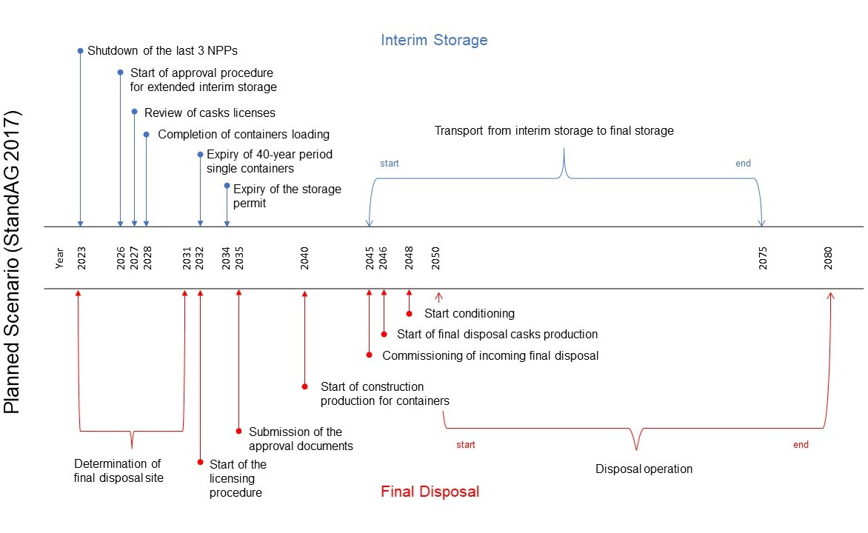

Source: Figure of (ESK 2023b). Translated and modified slightly.

Notes: Timeline based on Site Selection Act 2017 and the National Waste Disposal Program 2015 (StandAG 2017; BASE 2020)

### Final Disposal Milestones

The following is an overview of milestones to be carried out by BGE. Figure ‎4‑2 above illustrates these milestones for both state-owned companies (BGZ and BGE). The first project of the BGE regarding the final storage of nuclear waste is the determination of the final disposal site, which is termed the “Site Selection Procedure” (BMJ 2023). The selection process aims to provide a participative, science-based, transparent, and adaptive method for locating the safest site to dispose of domestically produced HLW (BMJ 2023). Due to its relevance for this work, this procedure and its phases will be briefly introduced. Moreover, LILW disposal is planned to be disposed of in the “Schacht Konrad” site, with an opening facility planned for 2027 (BGE 2023a; 2023g; 2022).

**Site Selection Procedure: Phase I**

First, BGE analyzes data to determine suitable subregions, considering geological criteria for safe disposal in Germany. Unsuitable areas are excluded, and only those meeting all minimum requirements and favorable scientific evaluation remain in the process. The intermediate report "Subregions" is then published by BGE, followed by public participation through legally mandated conferences (BGE 2023d; BASE 2022a). Second, safety assessments for potential subregions are conducted. Based on the outcomes, the BGE proposes areas to be investigated above ground, and the legislator decides on the regions to be explored (BGE 2023c).

**Site Selection Procedure: Phase II**

BGE explores the selected regions according to site-specific exploration programs. The results are incorporated into further safety assessments, and socio-economic potential analyses are discussed. The findings of this phase lead to proposals for underground exploration sites (BGE 2023c; 2023b).

BGE conducts detailed underground exploration, forming comprehensive safety assessments and a comparative evaluation of the sites. Later on, the BASE initiates an environmental impact assessment (BASE 2022a).

**Site Selection Procedure: Phase III**

Finally, after finalizing the third phase, BASE reviews the BGE's proposal, weighing all private and public interests, and recommends the safest site to the Federal Ministry for the Environment, Nature Conservation, and Nuclear Safety (BASE 2022a). It is important to note that the final decision on the site lies with the legislator (BMJ 2023).

Along this procedure, the first milestone includes the successive development of final disposal container concepts for all host rocks, which the BGE carries as a separate project.

**Post-Site Selection Procedure**

2032, the approval process for the disposal repository, treatment facility, input/output storage, and final disposal containers begins. By 2035, the documents for this approval process are set to be submitted (ESK 2023b). Later in 2040, approvals for the construction of the final repository, the input/output storage, and the conditioning plant must be available; in 2045, the incoming final disposal will be commissioned. From 2046, production of final disposal casks starts with capacities for 1,870 final repository containers (i.e., approx. 60/year) or 5,940 final repository coquilles plus packaging (i.e., approx. 200/year) and transfer containers for 3,900 glass coquilles will be required over 30 years. In 2048, the start of conditioning phase starts. This process will handle approximately 340 Mg SM/a (spent material a year) and around 130 glass coquilles per year over 30 years. Final repository containers must be available when conditioning operations commence (ESK 2023b).

The actual disposal procedure will take place from 2050 until 2080. Depending on the final repository container design, an average of approx. 60 - 200 final repository containers with fuel elements and approx. One hundred thirty glass coquilles per year must be disposed of over these 30 years (ESK 2023b).

### Data

There is inherent uncertainty in estimating the costs for the long-term funding of radioactive material. The costs cannot be reliably predicted, and it is unclear when exactly precise payments will be required (Irrek 2023; Irrek and Tammen 2014). On the one hand, the "Expert Opinion on the Evaluation of Provisions in the Nuclear Energy Sector" of the auditing firm (Warth & Klein Grant Thornton 2015) commissioned by the Federal Ministry of Economics and Climate Protection (BMWi) proved to be particularly effective (Ludwigs 2018). A detailed waste disposal cost projection was provided as part of this so-called stress test. **Error! Reference source not found.** presents the main takeaways of the cost projections per category.

Table ‎4‑1: Cost Projections of Nuclear Waste Management in Germany (Million EUR2014).

|  |  |  |
| --- | --- | --- |
| **Cost Category** | **Undiscounted Costs 2023-2099 in Prices of 2014 (M. EUR)** | **Discounted Costs 2023-2099 with NSCI of 1.97% and IR of 1.60% (M. EUR)** |
| **Interim Storage** | 4,985 | 25,496 |
| **Casks, Transport, and Operational Wastes** | 6,342 | 46,371 |
| **Decommissioning and Dismantling** | 13,256 | 21,544 |
| **LILW Disposal (Schacht Konrad)** | 2,334 | 7,347 |
| **HLW Disposal** | 7,271 | 45,240 |
| **Total Costs** | **34,188** | **145,998** |

Abbreviations used: IR = Inflation Rate; NSCI = Nuclear-Specific Cost Increase; M. EUR = Million Euro

Source: Own depiction based on (Warth & Klein Grant Thornton 2015).

Experts of the auditing firm have also emphasized that the conducted cost prognosis of disposal costs are associated with significant estimation uncertainties since the actual costs of decommissioning of NPPs, interim storage, transportation, and containers, and final disposal of nuclear waste, along with all associated necessary measures, are strongly depended on several factors. Namely, the inflation rate, nuclear-related cost increases, and discount rate might vary extensively depending on economic and political conflicts (Warth & Klein Grant Thornton 2015).

In this work, the detailed cost estimation prognosis[4] on the expenses of nuclear waste management of Grant Thornton, along with several official federal budget reports published by the German government and several reports of ministerial-related entities such as BMWK, BGZ, BGE, and BASE, are being considered for conducting an updated cost projection (BMUV 2022; BGE 2019; 2020; 2021; 2022; 2023g; BGZ 2023a; 2023c).

### Funding of Nuclear Waste Management

In 2016, an agreement was reached for nuclear energy supply companies to pay into an externally managed fund, ensuring long-term liquidity and financing for radioactive waste disposal (BMJ 2017b). The Waste Disposal Fund Act came into force on June 16, 2017, leading to the establishment of the KENFO (BMJ 2017a). In July 2017, the 25 German nuclear power plant operators deposited a total of €24.1 billion into KENFO’s accounts, securing the financing of interim storage and final disposal of radioactive waste (KENFO 2023a). BMWK oversees the fund in consultation with the BMF and BMUV. With €24.1 billion in managed funds, KENFO is Germany's largest public law foundation. By 2017, the Law on the Reorganization of Responsibility in Nuclear Waste Disposal took effect, shifting the responsibility from energy suppliers to the state (BMJ 2017b). They were obligated to pay €17.389 billion, leading to the creation of KENFO, with an additional voluntary risk surcharge of 35.47%. This allowed the state to forgo future payment obligations in case of liquidity problems with KENFO, and KENFO began securing the long-term financing of disposal with assets of €23.556 billion (KENFO 2023a). A study by Warth & Klein Grant Thornton AG estimated the disposal costs at €27.8 billion in 2015. With a nuclear-specific cost increase rate of 1.97%, these costs could rise to nearly €140 billion for 2015-2099 (Warth & Klein Grant Thornton 2015). It is important to note that in the previous year (2022), KENFO experienced a deprecation of approximately €3.1 billion. This represents a 12.2% decrease compared to the prior year (KENFO 2023c; Hoh 2023).

This analysis shows that Germany ought to expect less expenses, mainly since the costs of interim storage are expected until 2075 instead of 2098. Moreover, the costs of containers, transport, operational waste, and the HAW final disposal site[5] are expected to vanish after 2080, whereas the auditing firm presumes a longer timeline, which ends in 2098. Thus, the external German fund ought to calculate with total cost projections of ***€72 billion,*** which is around ***€46 billion*** cheaper than the auditing firm estimated (Warth & Klein Grant Thornton 2015)[6]. Nevertheless, with an initial fund amount of ***€21.7 billion,*** KENFO needs a yearly ROI of ***4.10%***[7]. We assume an inflation rate of 1.60% and a nuclear-specific cost increase of 1.97%. The long-term average target ROI of KENFO is 3.90% (Mikus 2020). This indicates that despite having fewer total cost projections, the ROI has to be higher since the timeframe does not allow for the compound interest effect of ROI. Hence, a clear definition of the economic problem from KENFO’s perspective is crucial. We have conducted an ex-ante analysis based on data presented in Section ‎4.3.3. After shrinking the proposed timeline by adapting it to the timeframe of StandAG (ESK 2023b)[8].

### Issue of Planned Scenario

As introduced in Section ‎4.3.2, Germany’s objective is to finish disposing of nuclear waste by 2080. In order to achieve this goal, several projects must be terminated as planned by the government by Site Selection Act. Among other projects, it necessitates the nomination of the final disposal site in 2031 and the commissioning of it by 2050 (BMJ 2023). According to recent reports, the site selection procedure will be delayed until at least the 2040s, with estimates suggesting completion of the procedure between 2046 and 2068 (ESK 2023b; BGE 2023c).

To put this in perspective, we have conducted an ex-post analysis regarding the cost estimations of three categories of NWM in Germany relevant to KENFO. These categories are: 1. Interim Storage, 2. LILW Disposal (Konrad Mine Repository), 3. HAW Disposal. After subtracting the actual costs reported by the German government from the estimated costs of Grant Thornton between 2017 and 2022, one obtains a relatively small deficit of ***€157 million***.

Table ‎4‑2: Ex-Post Analysis. Difference of Grant Thornton Prognosis and Actual Reported Costs of 2017-2022 (million EUR2023).

|  |  |  |  |  |  |  |  |  |  |  |  |  |
| --- | --- | --- | --- | --- | --- | --- | --- | --- | --- | --- | --- | --- |
| **Cost Category** | **Σ 2017-2022** | **2017** | | **2018** | | **2019** | | **2020** | | **2021** | | **2022** |
| **Interim Storage** | -1,565 | -268 | | -154 | | -293 | | -312 | | -307 | | -232 |
| **LILW Disposal (Schacht Konrad)** | -758 | -248 | | 6 | | -37 | | -214 | | -151 | | -114 |
| **HLW Disposal &CTOW**[9] | 2,166 | -24 | | 566 | | 514 | | 416 | | 352 | | 342 |
| **Total Costs** | -157 | -541 | 418 | | 184 | | -110 | | -105 | | -3 | |

Abbreviations uses: CTOW = Containers, Transport, and Operational Waste.

Source: Own depiction based on (Warth & Klein Grant Thornton 2015; BMUV 2022; BGE 2023g; 2022; 2020; 2021)

After comparing the cost estimations of Grant Thornton with federal budget reports for 2023-2027, as illustrated in Table ‎4‑3. A higher deficit of almost seven times is noticed. In contrast to the result of conducted ex-post analysis, the total costs as planned by BMUV amount to **€1.1 billion** for 2023-2027vs.previously estimated costs of **€0.16 billion** for 2017-2022.

Table ‎4‑3: Ex-Ante Analysis. Difference of Grant Thornton Prognosis and Federal Budget Plan of 2023-2027 (million EUR2023).

|  |  |  |  |  |  |  |  |  |  |  |  |
| --- | --- | --- | --- | --- | --- | --- | --- | --- | --- | --- | --- |
| **Cost Category** | **Σ 2023-2027** | **2023** | | **2024** | | **2025** | | **2026** | | **2027** | |
| **Interim Storage** | -1,508 | -304 | | -389 | | -414 | | -402 | | 0 | |
| **LILW Disposal (Schacht Konrad)** | -1,291 | -269 | | -300 | | -262 | | -244 | | -215 | |
| **HLW Disposal &CTOW**[10] | 1,709 | 347 | | 419 | | 403 | | 388 | | 151 | |
| **Total Costs** | -1,090 | -226 | -270 | | -273 | | -257 | | -64 | |

Abbreviations uses: CTOW = Containers, Transport, and Operational Waste.

Source: Own depiction based on (Warth & Klein Grant Thornton 2015; BMUV 2022; BGE 2023g; 2022; 2020; 2021)

As illustrated in Table ‎4‑3 and Figure ‎4‑3, the category of HLW disposal and containers, transport, and operational waste were overestimated for the whole considered timeline. In contrast, the rest of the categories were underestimated. A possible justification for this is the delay of the first project of the BGE concerning the nomination of the final disposal site, which will likely result in a postponement spanning decades across the entire process of nuclear disposal, and therefore resulting in extended time for interim storage, thereby extending the detention of nuclear waste in Germany (ESK 2023b).

Figure ‎4‑3: Ex-Ante Analysis. Difference of Grant Thornton Prognosis and Federal Budget Plan of 2023-2027 (million EUR2023)

Abbreviations uses: CTOW = Containers, Transport, and Operational Waste.

Source: Own depiction based on (Warth & Klein Grant Thornton 2015; BMUV 2022; BGE 2023g; 2022; 2020; 2021)

Suppose we were to assume that such a trend would continue throughout the project, along with the delay in determining the final disposal site. In that case, the total amount of additional interim storage will range between 25-37 years. Hence, the estimation of €140 billion[11] for 2015-2099, or €127 billion for 2023-2099 (Warth & Klein Grant Thornton 2015), is not realistic anymore. Hence, a novel cost projection of German NWM must be conducted for all possible timelines discussed in (ESK 2023b). This is significant to answer the crucial question regarding whether KENFO could ensure funding[12] German NWM or whether it would be deducted from taxpayers' pockets.

Therefore, this work aims to provide an economic evaluation of the long-term financing of nuclear waste. To achieve this, we define three realistic new timelines and define them as Germany’s new possible scenarios for NWM. The adjusted cost projections for these scenarios will be utilized to determine which average ROI KENFO must achieve throughout the years to secure covering the costs of German NWM.

These scenarios substitute the planned scenario discussed in subsection ‎4.3. However, it is important to state that the following scenarios are only an adaptation based on the current status of milestones reports of governmental entities (ESK 2023b). The following subsections will define and discuss these scenarios, termed with best, medium, and worst-case scenarios.

## Best Case Scenario

According to (ESK 2023b), the annual report of BGE regarding the progress of the site selection procedure (BGE 2023g), in which the following was stated: "... it is also clear that the timeframe mentioned in the Site Selection Act up to 2031 is not a realistic timeframe to find a repository for high-level radioactive waste.". As an alternative, they have adopted a new time frame from 2046 to 2068 for the closure of the site selection procedure. Hence, in the best case scenario, the final disposal site will be determined in 2046 (ESK 2023b; BGE 2023g). The following figure provides an adjusted illustration of the main milestones of both interim storage and final disposal projects. The main difference between this adapted timeline and the planned timeline is the postponement of the end of the site selection procedure. Therefore, the disposal operation must be delayed accordingly with 15 years at best. As a result, German nuclear waste must stay during this period in sites for interim storage.

Figure ‎4‑4: Milestones Timeline of Best Case Scenario

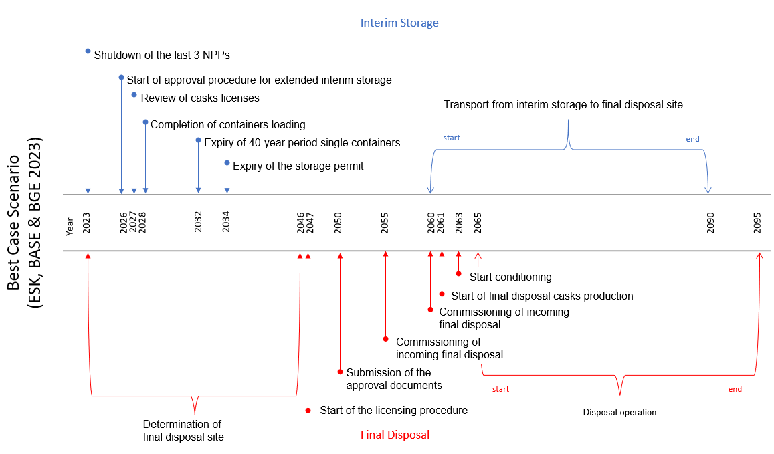

Source: Own depiction based on (BGE 2023g; ESK 2023b)

### Assumptions

We must define several assumptions to examine the economic consequences of the previously mentioned delays on both interim storage and final disposal of German nuclear waste management. Since the nature of the projects is full of uncertainties concerning predictions about prospective inflation rates, nuclear-related increases in cost, delays in projects, and much more. First, we assume the completion site selection procedure will be in 2046, hence the best case scenario. Second, we presume a long-term inflation rate of 1.60%[13]. Third, we suppose a future nuclear-specific cost increase of 1.97%[14]. Finally, we presume a long-term return target of investment for KENFO of 3.90%[15]. The previously mentioned rates are to be considered as yearly averages for simplification of calculation.

### Long-Term Cost Projections

We have conducted an ax-ante analysis to estimate cost estimations for German NWM[16]. Therefore, we took the detailed cost projection[17] of the auditing firm as a basis. Afterward, we retrieved previous official reports to correct this cost projection (BMUV 2022; BGE 2023g). Furthermore, we have adapted the timelines of the original cost projection table of Grant Thornton by considering actual reports on project postponements of the Site Selection Act (BMJ 2023; ESK 2023b). As seen in Best Case Scenario Cost Projection (see Appendix 5), three tables are presented. In each table, the following categories are given a cost estimation value:

* Interim Storage
* Containers, Transport & Operational waste
* LILW Disposal (Konrad repository)
* HAW Disposal[18]
* Total of all categories

The first table shows the original table of Grant Thornton's prognosis. The second one presents the corrected table based on governmental budget reports. The third highlights the outcome of subtracting the second table from the first, resulting in the calculated yearly surplus or deficit for each respective year from 2023-2096. According to the ex-ante analysis, the German government has to plan with a deficit of ***€1.4 Billion*** for cost projection for Σ2023-2096, which strongly depends on the assumptions mentioned above and other factors (wars, economic crisis, etc.), which were ignored in the analysis. More specifically, for this analysis, for one thing, the total of all cost categories for years 2023-2027, according to Grant Thornton's cost projection,[19] is almost ***€2.5 billion***. In contrast, the total allocated budget for the same projects is almost ***€4.8 billion*** (BMUV 2022), resulting in a deficit of ***€2.3 billion*** only in the first five yeast of the cost projections. On the other hand, the planned closure, according to Grant Thornton, was set to 2098; in the best case scenario, according to (ESK 2023b), this is set to 2095. This one adjustment results in a surplus of nearly ***€1 billion***[20]. With the inflation mentioned above rate, future nuclear-specific cost increase, and target ROI of KENFO, KENFO will be able to cover forthcoming cost projections from 2023 until 2074. From 2075 onwards, the fund’s balance will go below zero at the end of each year, signaling the need for help from an external entity.

### Long-Term Target ROI

In the previous subsection, the estimated costs were presented; conversely, the long-term financing required to cover these costs will be discussed in this subsection. As discussed in Section ‎3, from the perspective of an external segregated fund, the fund's objective is to determine the least possible target ROI that ensures long-term financing. We use the mathematical formulation of the economic problem as defined in the previously mentioned subsection and the proposed method to solve it. More specifically, in the best case scenario, which does not mean the lowest possible cost projections based on the lowest inflation rate and cost increase in the nuclear waste industry, but rather it refers to the most reasonably economical possible cost projections according to the previous two subsections, which are strongly depended on the timeframes of projects of both the BGE and BGZ. The following describes the problem at hand by substituting the given parameters of the previously proposed minimization problem.

After substituting the cost projections in the method introduced in subsection ‎3.2 with the following input.

*Costs* Projections[21]*:* { *0.90, 1.01, 1.01, 1.00, 0.88, 0.69, 0.69, 0.70, 0.73, 0.81, 0.52, 0.51, 0.53, 0.69, 0.48, 0.50, 0.47, 0.48, 0.45, 0.47, 0.48, 0.50, 0.52, 0.66, 1.01, 1.22, 1.44, 2.19, 2.08, 1.96, 1.61, 1.20, 1.31, 1.36, 1.40, 1.64, 1.70, 1.76, 1.83, 1.89, 1.42, 1.47, 1.47, 1.52, 1.57, 1.61, 1.67, 1.73, 1.80, 1.86, 1.93, 2.00, 2.07, 2.14, 2.22, 2.30, 2.38, 2.33, 2.58, 2.66, 2.83, 2.87, 3.00, 3.08, 3.12, 3.29, 2.71, 2.88, 2.68, 2.78, 2.88, 3.71, 3.85, 0.00*}

*ROI*[22]: The Return on Investment expressed as a percentage. The average rate of return must be achieved each year to cover the projected costs.

*Fund Balance t =* 2022[23]:€ 21.7 billion.

After substituting the cost projections and initial fund balance in the function described in Algorithm 1[24]. After substituting the two previously mentioned input variables (initial fund balance cost projections), the function returns the result of target ROI = 4.64%[25]. As mentioned in ‎4.4.1, the declared target ROI of KENFO amounts to 3.90% (Mikus 2020). This result indicates that KENFO needs to achieve an average ROI of 4.64% to cover the cost projections.

## Medium Case Scenario

Using the same analogy of the previous subsection, we define the following scenario by determining the final disposal site in the average of the communicated delay as stated by (ESK 2023b). Hence, we find the middle of 2046-2068, i.e., 2057. The expected execution of the BGZ and BGE milestones has to be adapted accordingly. This results in a delay of 26 years. We explore, therefore, several possible consequences of such postponement. The following figure illustrates this section's adapted timeframes of the defined scenario. Compared to the previous scenario, nuclear waste should sit until 2101 instead of 2090. The detailed timeline of this scenario is listed in Appendix 7.

### Assumptions

Given that these projects are riddled with uncertainties, including potential inflation rates, cost escalations related to nuclear prices, project postponements, and other factors, it is therefore crucial to set assumptions. First, presuming the completion of the site selection procedure in 2057. The conducted ex-ante analysis must be adapted so that resulting postponements of interim storage, transport, and actual construction of the final disposal site are taken into consideration by stretching timeframes of cost components[26]. Second, we define a long-term inflation rate of 1.72%[27], which is the calculated average of previous German inflation rates between 1992 and 2021. Third, we suppose a future nuclear-specific discount rate of 1.97%[28]. Finally, we presume a long-term return target of investment for KENFO of 3.90%[29]. The previously mentioned rates are to be considered as yearly averages for simplification of calculation.

### Long-Term Cost Projections

Similar to subsection ‎4.4.2, we undertook an ex-ante analysis to evaluate cost predictions related to nuclear waste management in Germany[30]. As seen in Appendix 8, the first table displays Grant Thornton's initial cost forecast for 2015. The second table offers a revised version, adjusted based on government budget reports. The third table illustrates the difference between the first and second tables, providing a yearly surplus or deficit calculation for each year from 2023 to 2107. According to the ex-ante analysis, the German government should calculate a deficit of ***€42 billion*** between 2023 and 2107, which strongly depends on the abovementioned assumptions.

### Long-Term Target ROI

In the preceding subsection, we detailed the projected costs. This section, however, presents the long-term ROI needed to cover these costs. Managing these cost projections falls on the German segregated fund, KENFO. As discussed in subsection 3.1, from an external segregated fund's viewpoint, the fund's goal is to determine the minimal target ROI that guarantees sustained financing. We use the same method of subsection ‎4.4.3 to find the least possible ROI. We substitute the input variables as follows into Algorithm 1, almost exactly as done in the previously mentioned section.

The following changes for algorithm inputs have to be specified for the current scenario:

*Costs t* ∈ Costs Projections

*Costs* Projections[31]*:* { *0.90, 1.01, 1.01, 1.00, 0.89, 0.70, 0.70, 0.71, 0.74, 0.82, 0.53, 0.53, 0.55, 0.71, 0.50, 0.51, 0.48, 0.50, 0.46, 0.48, 0.50, 0.52, 0.54, 0.69, 1.05, 1.27, 1.50, 2.28, 2.17, 2.05, 1.69, 1.26, 1.37, 1.43, 1.47, 1.73, 1.79, 1.86, 1.93, 2.00, 1.51, 1.56, 1.56, 1.61, 1.67, 1.72, 1.79, 1.85, 1.92, 1.99, 2.07, 2.14, 2.22, 2.31, 2.39, 2.48, 2.57, 2.52, 2.79, 2.88, 3.07, 3.12, 3.26, 3.35, 3.41, 3.59, 2.97, 3.16, 3.19, 3.27, 3.40, 4.23, 4.39, 4.55, 4.72, 4.90, 5.08, 5.27, 5.47, 3.75, 3.89, 4.03, 4.18, 4.34, 0.00*}

*ROI*[32]: The Return on Investment expressed as a percentage. The average rate of return must be achieved each year to cover the projected costs.

*Fund Balance t =* 2022[33]:€ 21.7 billion

After running the Java code, we receive a value of the required yearly ROI: 5.00%[34]. The from KENFO set target ROI equals 3.90% (Mikus 2020). This means that KENFO must raise its average ROI by 1.10% for the abovementioned timeframe, inflation rate, and cost estimations to cover nuclear waste management costs.

## Worst Case Scenario

Drawing from the analogy in the preceding two subsections, we establish the subsequent scenario by exploring the worst possibility of completion of the final disposal site. This places us at the end of 2046-2068, specifically 2068. The projected timelines for BGZ and BGE milestones must hence be adjusted accordingly. As per the interpretation of (ESK 2023b), Germany expects to complete interim storage and final disposal projects by 2080. Contrary to this, in our current scenario, the disposal process, as stated by BGE, is anticipated to conclude (in the worst case) in 2117, indicating a delay of 37 years. Therefore, we dig into the potential implications of such a prolonged timeline. Appendix 10 shows the adjusted timelines for this particular scenario. In contrast to the earlier scenario, nuclear waste is projected to remain until 2112, as opposed to 2101. Both transport duration from interim storage into the final disposal site and actual disposal operation still requires 30 years (ESK 2023b; BGE 2023g)

### Assumptions

It is necessary to lay down specific assumptions to evaluate the economic repercussions of the previously mentioned delays in both interim storage and final disposal within Germany's nuclear waste management. First, we presume that the site selection process will conclude in 2068. As such, the ex-ante analysis has undertaken modifications to account for the subsequent delays in interim storage, transportation, and the actual construction of the final disposal site by extending the timeframes associated with cost elements[35]. Second, we define a long-term inflation rate of 1.72%[36], the average of previous German inflation rates between 1992 and 2021. Third, we suppose a future nuclear-specific cost increase (also referred to as nuclear increases or nuclear cost growth) of 1.97%[37]. Finally, we presume a long-term return target of investment for KENFO of 3.90%[38]. The previously mentioned rates are to be considered as yearly averages for simplification of calculation.

### Long-Term Cost Projections

In this study, we undertook an ex-ante analysis to evaluate cost predictions related to nuclear waste management in Germany. We based our initial assessment on the comprehensive cost forecast provided by Grant Thornton in 2015[39]. To refine this, we used past federal budget reports to update the projection with actual expenses officially disclosed by the German federal government from 2015 to 2023.

Similar to the last two subsections, we introduce the conducted ex-ante analysis. The first table displays Grant Thornton's initial cost forecast for 2015. The second table offers a revised version, adjusted based on government budget reports. The third table illustrates the difference between the first and second tables, providing a yearly surplus or deficit calculation for each year from 2023 to 2118. According to the ex-ante analysis, the German government should calculate a deficit of almost €74 billion between 2023-2118, which strongly depends on the above assumptions.

### Long-Term Target ROI

Managing previously mentioned cost projections falls on the German segregated fund, KENFO. We use the same method of Section 4.4.3 to find the least possible ROI, which ensures covering the projected costs based on the adapted calculation of those. We substitute the input variables into Algorithm 1, almost exactly as done in the previously mentioned section.

The following changes for algorithm inputs have to be specified for the current scenario:

*Costs t* ∈ Costs Projections

*Costs* Projections[40]*:* { *0.90, 1.01, 1.01, 1.00, 0.89, 0.70, 0.70, 0.71, 0.74, 0.82, 0.53, 0.53, 0.55, 0.71, 0.50, 0.51, 0.48, 0.50, 0.46, 0.48, 0.50, 0.52, 0.54, 0.69, 1.05, 1.27, 1.50, 2.28, 2.17, 2.05, 1.69, 1.26, 1.37, 1.43, 1.47, 1.73, 1.79, 1.86, 1.93, 2.00, 1.51, 1.56, 1.56, 1.61, 1.67, 1.72, 1.79, 1.85, 1.92, 1.99, 2.07, 2.14, 2.22, 2.31, 2.39, 2.48, 2.57, 2.52, 2.79, 2.88, 3.07, 3.12, 3.26, 3.35, 3.41, 3.59, 2.97, 3.16, 3.19, 3.27, 3.40, 4.23, 4.39, 4.55, 4.72, 4.90, 5.08, 5.27, 5.47, 5.67, 5.88, 6.10, 6.33, 6.56, 6.81, 7.06, 7.32, 7.60, 7.88, 8.17, 5.60, 5.81, 6.03, 6.25, 6.48, 0.00*}

*ROI*[41]: The Return on Investment expressed as a percentage. The average rate of return must be achieved each year to cover the projected costs.

*Fund Balance t =* 2022[42]:€ 21.7 billion

After running the Java code, we receive a value of the required yearly ROI of 5.17%[43]. The KENFO set target ROI equals 3.90% (Mikus 2020). This means that KENFO must raise its average ROI by 1.27% for the abovementioned timeframe, inflation rate, and cost estimations to cover nuclear waste management costs.

# Results

In the presented case study, four distinct scenarios were evaluated. Each of these scenarios incorporated varying assumptions regarding timelines of nuclear waste management in Germany, inflation rates, and nuclear-specific discount rates. A concise description of each scenario is provided in the following, followed by a comparative analysis of the results.

## Scenarios Definition

**Scenario 1 (“Planned”):** The first scenario reflects the current status quo in Germany. According to the legal framework (BMJ 2023), there is a clear directive that the final disposal site ***should*** be determined by 2031. Based on this assumption, a cost projection timeline has been established for 2023-2080 (ESK 2023b). This timeline indicates that the disposal operation will occur between 2050-2080. Consequently, the final batch of waste currently in interim storage should be transported by 2075. The economic ex-ante analysis based on this timeline presumes an inflation rate of 1.60% and a nuclear-specific discount rate of 1.97% (Warth & Klein Grant Thornton 2015).

**Scenario 2 (“Best-Case”):** This scenario evaluates the current status of the site selection procedure based on recent reports (ESK 2023b; BGE 2023g). These reports suggest a unanimous agreement on a procedural delay in site selection. Under the most favorable conditions, the site should be chosen by 2046. The projected cost timeline has been revised to cover 2023-2095. It is projected that waste operation for final disposal will occur between 2050 and 2095. Therefore, the final waste transfer from interim storage is expected by 2090. Using this revised timeline, the economic ex-ante analysis presumes an inflation rate of 1.60% and a specific nuclear cost escalation of 1.97%.

**Scenario 3 (“Medium-Case”):** This scenario also assesses the current status of the site selection procedure, referencing the same reports (ESK 2023b; BGE 2023g). The consensus points to a delay in the site selection, with a realistic completion by 2057. Consequently, the cost projection timeline has been updated to range from 2023 to 2106. Waste is a final disposal operation forecasted between 2076 and 2095, implying that the final transfer from interim storage should conclude by 2076. Based on this updated timeline, the economic ex-ante analysis assumes an inflation rate of 1.72% and a consistent nuclear cost increase of 1.97%.

**Scenario 4 (“Worst-Case”):** The fourth scenario recognizes the current progress of the site selection procedure, based on the previously mentioned reports on the postponement in the site selection procedure (ESK 2023b; BGE 2023g). Pessimistically, we presume a completion of the procedure by 2068. As a result, the cost projection timeline has been extended to 2023-2117. The anticipated period for final disposal operation is between 2087 and 2095. Thus, the final transfer from interim storage is projected for 2076. The economic ex-ante analysis, aligned with this extended timeline, considers an inflation rate of 1.72% and a nuclear cost rise of 1.97%.

## Scenarios Comparison

As of November 2020, the segregated external German fund (KENFO) has communicated its long-term target ROI of 3.90%, based on the cost projections and status at the time (Mikus 2020). The fund’s balance on 31.12.2019 was above ***€23 billion***[44] (KENFO 2023c). If one were to assume having the exact previously mentioned amount in the balance as of 31.12.2022 and the same inflation rate and nuclear-specific costs increase as defined in the first scenario. According to StandAG, KENFO should cover the projected costs only for the planned scenario by its 3.9% target ROI.

After applying the method explained in ‎3.2 and simulating the fund balance at each calendar year, we received the following results[45]:

* The fund covers estimated costs with a final balance of ***€7.6 billion*** in 2080.
* An average ROI of 3.75% would cover the costs with breaking even[46].

However, KENFO has reported a balance of ***€21.7 billion*** as of 31.12.22. With the target ROI at 3.90%, as mentioned by KENFO (Mikus 2020), the costs of NWM ***will not be covered in any of the four defined scenarios***. More specifically, the fund’s balance for the first two scenarios will suffice only until **2074** and for the last two scenarios until **2072**. After these years, KENFO would report a minus in its balance. These results indicate that KENFO must ensure a higher average ROI than its target to ensure sufficient funds throughout the extended timeline of NWM. Relatively, pumping enough more money into the fund could also be considered. Table ‎5‑1 lists the findings of the conducted ex-ante analysis regarding the actual cost projections of BGE and BGZ. The mentioned cost projections are inflated and escalated based on the assumptions of the corresponding scenario[47].

Table ‎5‑1: Comparison of Cost Projections and Required ROI Across Different Scenarios.

|  |  |  |  |  |  |
| --- | --- | --- | --- | --- | --- |
| **Scenario** | **Projects Timeframes** | **Assumptions** | **Cost Projections** | | **Required ROI** |
| **Planned** | 2023-2080 | IR = 1.60%  NSCI = 1.97% | €72 billion | 4.10% | |
| **Best-Case** | 2023-2095 | IR = 1.60%  NSCI = 1.97% | €120 billion | 4.64% | |
| **Medium-Case** | 2023-2106 | IR = 1.72%  NSCI = 1.97% | €179 billion | 5.00% | |
| **Worst-Case** | 2023-2117 | IR = 1.72%  NSCI = 1.97% | €264 billion | 5.17% | |

Abbreviations used: IR = Inflation Rate; NSCI = Nuclear-Specific Cost Increase

Source: Own depiction based on results of ex-ante analysis and balance simulation.

The first key insight from Table ‎5‑1 lies in the terminology of the scenarios. The planned scenario for NWM in Germany is, in fact, not realistic. Hence, it has been referred to as planned and not a best-case scenario (BGE 2023g; ESK 2023b; Irrek 2023). Therefore, defining the four timeframes for projects carried out by BGE and BGZ, as described in subsection ‎5.1, becomes critically important. This is particularly true given the substantial differences in timelines among the proposed alternative scenarios, which range from 15 to 37 years. Additionally, solving the mathematical and economic problem from the perspective of an external segregated fund, as discussed in Section ‎3.1, is highly dependent on various assumptions, such as inflation rate and cost increase, and, just as importantly, on the project’s timeframe.

Furthermore, another key takeaway is the noticeable increase in estimated cost trends in the scenarios. A longer timeframe of projects for BGZ and BGE results in significantly higher costs. This is because, for a postponement of time ***t\**** for the site selection procedure, German HLW and LILW must sit in interim storage for the extended time ***t\**** (ESK 2023b)***.***

Figure ‎5‑1 illustrates the cost estimation of the four previously mentioned scenarios. The total costs of each scenario are indicated in the cost projections of Table ‎5‑1[48].

Figure ‎5‑1: Comparison of Cost Projections of Scenarios

Source: Own depiction based on results of ex-ante analysis and balance simulation.

The third key takeaway of Table ‎5‑1 is the marginal increase of the required average ROI of KENFO despite the relatively large increase in cost projections in the four scenarios. For instance, comparing the first two scenarios, the second scenario's cost projections are 1.67 times higher than the first, a nearly ***€48 billion*** difference. However, the second scenario needs *only* a 0.54% higher average ROI to cover yearly costs[49]. Figure ‎5‑2 reveals fund balances of €14 billion and €36 billion for the first and second scenarios in 2070, respectively. Two key variables and their corresponding interpretations underlie the observed differences between the scenarios. Both scenarios assume consistent inflation and cost increases from 2023 to 2075, yet the first scenario benefits substantially from a marginally elevated ROI. Furthermore, the second scenario extends over an additional 15-year period, a factor that, in conjunction with the higher ROI from 2023 to 2075, accounts for the coverage of the extra €48 billion in projected costs[50].

Figure ‎5‑2: Fund Balance and Cost Projection Comparison of First and Second Scenarios for the Years 2070-2095

Source: Own depiction based on results of ex-ante analysis and balance simulation.

In the following a representation of the projected costs and required annual balance of KENFO for the four scenarios is presented below[51].

Figure ‎5‑3: Fund Balance vs. Cost Projection Across the Four Scenarios.

Source: Own depiction based on results of ex-ante analysis and balance simulation.

As mentioned in this subsection, the four scenarios depend strongly on the presumptions regarding the timeframes of projects, inflation rates, nuclear-specific cost increase, and target ROI. The following section will provide further discussion regarding the validation of results and these parameters.

# Discussion

## Results Validation

Given that the model is designed to forecast future pricing trends, its validation is inherently constrained to ex-post analysis. Nevertheless, the federal budget report provides proximate future price indicators, extending at times to a six-year horizon. These figures may provide provisional benchmarks for assessing the model's predictive accuracy. However, caution is advised in interpreting these indicators due to the speculative variables prevalent in the German NWM market. Further elaboration on the conducted ex-ante analysis and its possible fluctuations are available in Section ‎4.3.4.

Moreover, the cost projections throughout this work depend strongly on the cost estimations (Warth & Klein Grant Thornton 2015). Hence, prior to using this data, an ex-post analysis was conducted to determine whether the auditing firm’s cost estimation for the timelines 2017-2022[52] was accurate enough. The total of Grant Thornton’s estimation for the previously mentioned timeframe was almost €5.00 billion, and the numbers by the federal budget reports were almost €5.1 billion. The difference between these is almost €0.16 billion, which signals a deviation of 3.06%. Such a percentage is not ideal but acceptable in the context of this work. As discussed in ‎5.2, even with a relatively high increase in the cost projections, the required average ROI to cover these cost projections, according to the simulations, was marginally increased. More specifically, we consider the results of both increasing and decreasing the cost projections of the planned scenario by 3.06%. After increasing the costs by the mentioned percentage, the required ROI increased from 4.10% to 4.23%. After decreasing the costs of the same scenario by 3.06%, the required ROI dropped to 3.97%. As a result, we ought to calculate with a deviation of ±0.13% for each found average ROI, assuming that other variables such as inflation rate and nuclear-specific cost increases are equal to the presumptions.

## Sensitivity Analysis

The influence of independent variables on the model was assessed through a sensitivity analysis.

Three independent variables influence the only dependent variable of the model (required ROI). First, we defined a scope for each of the two independent variables of the model.

Table ‎6‑1: Range of Two of the Independent Variables.

|  |  |  |  |  |  |
| --- | --- | --- | --- | --- | --- |
| **Independent Variable** | **(1)** | **(2)** | **(3)** | **(4)** | **(5)** |
| **Inflation Rate** | 1.60% | 1.72% | 1.91% | 4.11% | 6.30% |
| **NS Cost Increase** | -1.97% | -1.00% | 0.00% | 1.00% | 1.97% |
| **Projects Timelines** | Best Case | Medium Case | Worst Case | - | - |

Abbreviations used: NS = Nuclear-Specific

Source: Own depiction

The three project timelines are detailed in Sections ‎4.4, ‎4.5, and ‎4.6, respectively. For each scenario, i.e., different project timelines, five variations of inflation rate and five variations of nuclear-specific cost increase were conducted. Table ‎6‑2 shows all combinations[53] created for the sensitivity analysis.

Table ‎6‑2: Sensitivity Analysis Total Variations.

|  |  |  |  |  |  |
| --- | --- | --- | --- | --- | --- |
| **Combination Number** | **(1)** | **(2)** | **…** | **(74)** | **(75)** |
| **Inflation Rate** | 1.60% | 1.60% | … | 6.30% | 6.30% |
| **NS Cost Increase** | -1.97% | -1.00% | … | 1.00% | 1.97% |
| **Project Timeline** | BCS | BCS | … | WCS | WCS |
| **Required ROI** | ROI(1) | ROI(2) | … | ROI(74) | ROI(75) |

Abbreviations used: NS = Nuclear-Specific; ROI = Return On Investment; BCS = Best Case Scenario; WCS = Worst Case Scenario

Source: Own depiction

After substituting the different inputs of the previous table in the algorithm described in ‎3.2 to find the least possible average ROI that assures covering the cost projections of the scenario, we receive the following results, which are illustrated using heat maps.

Figure ‎6‑1: Sensitivity Analysis Results.

|  |  |  |  |  |  |  |  |  |  |
| --- | --- | --- | --- | --- | --- | --- | --- | --- | --- |
|  | ***Best Case - Required ROI*** | | | | | |  |  |  |
|  |  | *Nuclear-Specific Cost Increase* | | | | |  |  |  |
| *Inflation Rate* |  | *-1.97%* | *-1.00%* | *0.00%* | *1.00%* | *1.97%* |  |  | 10.96% |
| *1.60%* |  |  |  |  |  |  |  |  |
| *1.72%* |  |  |  |  |  |  |  |  |
| *1.91%* |  |  |  |  |  |  |  |  |
| *4.11%* |  |  |  |  |  |  |  |  |
| *6.30%* |  |  |  |  |  |  |  |  |
|  |  |  |  |  |  |  |  |  | 5.76% |
|  | ***Medium Case - Required ROI*** | | | | | |  |  |  |
|  |  | *Nuclear-Specific Cost Increase* | | | | |  |  |  |
| *Inflation Rate* |  | *-1.97%* | *-1.00%* | *0.00%* | *1.00%* | *1.97%* |  |  |  |
| *1.60%* |  |  |  |  |  |  |  |  |
| *1.72%* |  |  |  |  |  |  |  | 3.98% |
| *1.91%* |  |  |  |  |  |  |  |  |
| *4.11%* |  |  |  |  |  |  |  |  |
| *6.30%* |  |  |  |  |  |  |  |  |
|  |  |  |  |  |  |  |  |  |  |
|  | ***Worst Case - Required ROI*** | | | | | |  |  | 2.61% |
|  |  | *Nuclear-Specific Cost Increase* | | | | |  |  |  |
| *Inflation Rate* |  | *-1.97%* | *-1.00%* | *0.00%* | *1.00%* | *1.97%* |  |  |  |
| *1.60%* |  |  |  |  |  |  |  |  |
| *1.72%* |  |  |  |  |  |  |  |  |
| *1.91%* |  |  |  |  |  |  |  |  |
| *4.11%* |  |  |  |  |  |  |  |  |
| *6.30%* |  |  |  |  |  |  |  | 0.37% |

Source: Own depiction

# Conclusions

This thesis aims to assess the long-term financing of nuclear waste management in Germany. Specifically, we aim to determine whether KENFO, the state fund responsible for this task, can cover the upcoming costs or if taxpayer intervention will be necessary. To answer such a complex question, several points were thoroughly considered.

First, after evaluation, the current NWM plan is defined under the German StandAG Act (BMJ 2023). We deduce that project timelines of the current German act on searching and selecting a site for a final disposal site for HLW must be discussed publicly and finally adopted by the legislator. The reason for that is that the federal company responsible for this task (BGE) has reported that the proposed year for the determination of the site (2031) is unrealistic (BGE 2023g). Alternative to the mentioned year, the federal company suggested the timeframe 2046-2068 for nominating the disposal site (ESK 2023b).

Second, the previously mentioned point necessitates that all stakeholders in NWM raise the transparency- and cooperation degree since the site selection procedure produces a chain effect. The extended timeline for site selection has a domino effect. It means that high-level and low-level nuclear waste will remain in interim storage facilities for a longer period. BGZ, the company responsible for interim storage, uses containers designed for 30 years, so the implications of extended storage need further study.

Third, delays in commissioning the "Schacht Konrad" site for LILW have led to logistical challenges and potential cost increases. Originally identified as a storage site in 1982 and later approved by legislators in 2002, the site's opening has been postponed multiple times, with the current target set for 2027[54] (BGE 2023g; 2022). As of 2023, there is no clear plan for waste delivery to this site, adding to the uncertainties. Any further delays in this project must be further considered since its economic consequences are the responsibility of KENFO.

Fourth, the main challenge is the economic implication for such postponement is the long-term funding of the whole project. We have conducted an ex-ante analysis for 3 + 1 scenarios to explore this challenge. The first scenario represents the current state of StandAG, and the three others recognize current reports of several governmental entities and adapt the expected costs on the developed timelines. As presented in Section ‎5, in neither of the four considered scenarios (planned, best, medium, and worst case scenario), will KENFO have enough liquidity to cover the projected costs? More specifically, according to the best case scenario[55], KENFO must increase its average ROI from 3.90% to 4.64%. One of the reasons for that is that KENFO has reported a huge loss in the previous year (2022), which accounts for 12.2% compared to its previous year. In fact, according to the conducted simulations of KENFO’s balance of the developed four scenarios, the state fund ought to run out of liquidity in the early 2070s. This strongly depends on the presumptions undertaken in the previously mentioned section.

In conclusion, KENFO must either raise its target ROI or apply for assistance from the federal government to ensure long-term financing of forthcoming interim storage and final disposal costs of German nuclear waste management. In summary, the project timelines are extended, resulting in cost overruns. The fund responsible for covering the project costs reports substantial liquidity losses, which does not signal the robust statement expected from a state fund commissioned with such a significant mission. Based on the previously mentioned points, The former option raises questions regarding the risk of the investment since a higher target ROI is generally accompanied by higher risks. In contrast, the latter option indicates that tax-payers must take responsibility for the matter. Thus, we recommend that the legislator conduct a new economic evaluation and public debate on the implications of presented challenges and possible solutions.

# References

Banerjee, Debasis, Amy J. Cairns, Jian Liu, Radha K. Motkuri, Satish K. Nune, Carlos A. Fernandez, Rajamani Krishna, Denis M. Strachan, and Praveen K. Thallapally. 2015. “Potential of Metal–Organic Frameworks for Separation of Xenon and Krypton.” *Accounts of Chemical Research* 48 (2): 211–19. https://doi.org/10.1021/ar5003126.

BASE. 2015. “2011/70/Euratom EU Directive on the Disposal of Radioactive Waste.” November 12, 2015. https://www.base.bund.de/EN/bfe/archive/bfs-statements/EN/2011/02-17-eu-directive.html.

———. 2019a. “Expert Information: Approval Procedure.” 2019. https://www.base.bund.de/EN/nwm/approval_of_packages/expert_information/expert-information_node.html.

———. 2019b. “Overview: When Is an Approval Procedure Required?” December 3, 2019. https://www.base.bund.de/EN/nwm/transports/introduction/introduction_node.html.

———. 2020. “National Waste Management Programme.” 2020. https://www.base.bund.de/EN/nwm/waste/napro/napro.html.

———. 2022a. “Site Selection Procedure.” January 12, 2022. https://www.base.bund.de/EN/soa/siteselectionprocess/siteselectionprocess_node.html.

———. 2022b. “Licensing of Nuclear Fuel Transports.” July 12, 2022. https://www.base.bund.de/EN/nwm/transports/licence/licence_node.html.

———. 2022c. “Tasks Performed by BASE.” August 2, 2022. https://www.base.bund.de/EN/bfe/tasks/tasks_node.html.

———. 2022d. “Licensing and Supervision.” September 12, 2022. https://www.base.bund.de/EN/ns/safety/licensing-supervision/licensing-supervision_node.html.

———. 2022e. “Safety and Security.” December 21, 2022. https://www.base.bund.de/EN/nwm/transports/introduction/introduction_node.html.

———. 2023. “The Nuclear Phase-Out In Germany.” April 19, 2023. https://www.base.bund.de/EN/ns/nuclear-phase-out/nuclear-phase-out_node.html.

Besnard, Manon, Marcos Buser, Ian Fairlie, Gordon MacKerron, Allison Macfarlane Eszter Matyas, Yves Marignac, Edvard Sequens, Johan Swahn, and Ben Wealer. 2019. “World Nuclear Waste Report.” Focus Europe. Berlin and Brussels. https://worldnuclearwastereport.org/.

BGE. 2019. “Geschäftsbericht 2018.” https://www.bge.de/fileadmin/user_upload/Organisation/Geschaeftsberichte/20190829-BGE_Geschaeftsbericht_2018_PDF_Version.pdf.

———. 2020. “Geschäftsbericht 2019.” https://www.bge.de/fileadmin/user_upload/Organisation/Geschaeftsberichte/20200914_BGE_Gescha__ftsbericht_2019_RZ_PDF_Version-WEB_.pdf.

———. 2021. “Geschäftsbericht 2020.” Peine. https://www.bge.de/fileadmin/user_upload/Organisation/Geschaeftsberichte/2020_BGE_Geschaeftsbericht_barrierefrei.pdf.

———. 2022. “Geschäftsbericht 2021.” Peine. https://www.bge.de/fileadmin/user_upload/Organisation/Geschaeftsberichte/20220331_BGE_Gescha__ftsbericht2021_barrierefrei.pdf.

———. 2023a. “Current Inventory.” https://www.bge.de/en/radioactive-waste/current-inventory/.

———. 2023b. “Phase I Step 2: Siting Regions.” 2023. https://www.bge.de/en/repository-search/siting-regions/.

———. 2023c. “Site Selection Procedure.” 2023. https://www.bge.de/en/repository-search/site-selection-procedure/.

———. 2023d. “Sub-Areas Interim Report.” 2023. https://www.bge.de/en/sitesearch/sub-areas-interim-report/.

———. 2023e. “Tasks.” 2023. https://www.bge.de/en/bge/tasks/.

———. 2023f. “The Company.” 2023. https://www.bge.de/en/bge/organisation/.

———. 2023g. “Geschäftsbericht 2022.” Peine. https://www.bge.de/fileadmin/user_upload/Organisation/Geschaeftsberichte/20230713_BGE_Geschaeftsbericht_2022_bf.pdf.

———. 2023h. “Zeitliche Betrachtung des Standortauswahlverfahrens aus Sicht der BGE.” Bundesgesellschaft für Endlagerung. https://www.bge.de/fileadmin/user_upload/Standortsuche/Wesentliche_Unterlagen/05_-_Meilensteine/Zeitliche_Betrachtung_des_Standortauswahlverfahrens_2022/20221216_Zeitliche_Betrachtung_StandAW-48_barrierefrei.pdf.

BGZ. 2023a. “Auftrag Sicherheit.” Wie die BGZ radioaktive Abfälle zwischenlagert. https://bgz.de/wp-content/uploads/2021/03/BGZ_Auftrag-Sicherheit_web.pdf.

———. 2023b. “Our Mandate.” 2023. https://bgz.de/en/our-mandate/.

———. 2023c. “Sichere Zwischenlagerung.” https://bgz.de/wp-content/uploads/2023/07/BGZ_Broschuere_Sichere-Zwischenlagerung.pdf.

BMJ. 2017a. *Gesetz zur Errichtung eines Fonds zur Finanzierung der kerntechnischen Entsorgung (Entsorgungsfondsgesetz - EntsorgFondsG)*. https://www.gesetze-im-internet.de/entsorgfondsg/BJNR011410017.html.

———. 2017b. *Gesetz zur Neuordnung der Verantwortung in der kerntechnischen Entsorgung*. https://www.gesetze-im-internet.de/vkenog/BJNR011409017.html.

———. 2018. *Gesetz über die Beaufsichtigung der Versicherungsunternehmen (Versicherungsaufsichtsgesetz - VAG)*. https://www.gesetze-im-internet.de/vag_2016/__124.html.

———. 2022. *Gesetz über die friedliche Verwendung der Kernenergie und den Schutz gegen ihre Gefahren (Atomgesetz)*. *§ 6 (5)*. https://www.gesetze-im-internet.de/atg/__6.html.

———. 2023. *Gesetz zur Suche und Auswahl eines Standortes für ein Endlager für hochradioaktive Abfälle (Standortauswahlgesetz - StandAG)*. https://www.gesetze-im-internet.de/standag_2017/BJNR107410017.html#BJNR107410017BJNG000100000.

BMUV. 2021. “Tasks and Structure.” September 12, 2021. https://www.bmuv.de/en/ministry/tasks-and-structure.

———. 2022. “BMUV-Haushalt 2023.” Haushaltsquerschnitt und Ergänzende Erläuterungen zum Einzelplan 16. https://www.bmuv.de/fileadmin/Daten_BMU/Download_PDF/Ministerium/gruenes_buch_2023_bf.pdf.

———. 2023. “Legal Provisions and Technical Rules and Regulations.” 2023. https://www.bmuv.de/en/topics/nuclear-safety/overview-nuclear-safety/legal-provisions-and-technical-rules-and-regulations.

Briggs, Th., P.L. Kunsch, and B. Mareschal. 1990. “Nuclear Waste Management: An Application of the Multicriteria PROMETHEE Methods.” *European Journal of Operational Research* 44 (1): 1–10. https://doi.org/10.1016/0377-2217(90)90308-X.

Bunn, Matthew, John P. Holdren, Steve Fetter, and Bob Van Der Zwaan. 2005. “The Economics of Reprocessing versus Direct Disposal of Spent Nuclear Fuel.” *Nuclear Technology* 150 (3): 209–30. https://doi.org/10.13182/NT05-A3618.

Clemmer, Steve, Jeremy Richardson, Sandra Sattler, and Dave Lochbaum. 2018. “The Nuclear Power Dilemma.” www.ucsusa.org/nucleardilemma.

ESK. 2023a. “Our Work.” 2023. https://www.entsorgungskommission.de/en/our_work.

———. 2023b. “Verlängerte Zwischenlagerung Bestrahlter Brennelemente Und Sonstiger Hochradioaktiver Abfälle in Abhängigkeit von Der Auswahl Des Endlagerstandorts.” https://umweltfairaendern.de/wp-content/uploads/2023/05/ESK_Positionspapier_verlaengerte_ZL_40plus_ESK105_23032023.pdf.

EWN. 2021. “Kernkraftwerk Rheinsberg - Geschichte, Stilllegung und Rückbau.” Rheinsberg: Entsorgungswerk für Nuklearanlagen. https://www.ewn-gmbh.de/fileadmin/user_upload/EWN/Projekte/Rueckbau_des_KKW_Rheinsberg/Brosch%C3%BCre_R%C3%BCckbau_KKR_10_2021.pdf.

Florian, Bitsch, Axel Buchner, and Christoph Kaserer. 2010. “Risk, Return and Cash Flow Characteristics of Infrastructure Fund Investments.” *EIB Papers* Vol. 15 (No. 1): 106–36.

Hoh, Daniel. 2023. “Deutscher Staatsfonds erleidet Milliardenverlust,” June 30, 2023. https://www.tagesschau.de/wirtschaft/finanzen/staatsfonds-deutschland-kenfo-milliardenverlust-100.html.

IAEA. 2006. *Fundamental Safety Principles*. Vol. 92-0-110706–4. IAEA Safety Standards, SF-1 Safety Fundamentals. https://www-pub.iaea.org/MTCD/Publications/PDF/Pub1273_web.pdf.

———. 2007. *Cost Considerations and Financing Mechanisms for the Disposal of Low and Intermediate Level Radioactive Waste*. IAEA-TECDOC 1552. Vienna: IAEA.

———. 2009a. *Classification of Radioactive Waste*. IAEA Safety Standards, GSG-1. https://www-pub.iaea.org/MTCD/publications/PDF/Pub1419_web.pdf.

———. 2009b. *Costing of Spent Nuclear Fuel Storage*. IAEA NUCLEAR ENERGY SERIES, NF-T-3.5. Vienna. https://www.iaea.org/sites/default/files/costingfuel0909.pdf.

———. 2009c. *Policies and Strategies for Radioactive Waste Management*. IAEA Nuclear Energy Series, NW-G-1.1. Vienna: Internat. Atomic Energy Agency.

———. 2014. *Radiation Protection and Safety of Radiation Sources: International Basic Safety Standards*. General Safety Requirements Part 3, No. GSR Part 3. Vienna.

———. 2017. *Selection of Technical Solutions for the Management of Radioactive Waste*. Vienna: IAEA.

———. 2022. *Status and Trends in Spent Fuel and Radioactive Waste Management*. IAEA Nuclear Energy. Vienna. https://www-pub.iaea.org/MTCD/Publications/PDF/PUB1963_web.pdf.

Irrek, Wolfgang. 2023. “Kosten der Langzeit-Zwischenlagerung und verlängerten Standortsuche.” Presented at the „Zwischen. Sicher? Ende?“ - atommuellreport.de, Hannover, Hannover, June 23. https://www.atommuellreport.de/fileadmin/Dateien/bilder/Projekte-Termine/20230623_AMR-Fachtagung_IrrekKosten.pdf.

Irrek, Wolfgang, and Hendrik Tammen. 2014. “• Was kosten Zwischenlagerung und Standortauswahlverfahren? • Reichen die Mittel des Fonds zur Finanzierung der kerntechnischen Entsorgung hierfür aus (KENFO)? • Wer trägt die Kosten, wenn die Fondsmittel nicht ausreichen? • Was bedeutet dies für den Zielkonflikt zwischen Kostenminimierung und Sicherheitsanforderungen?”

Kärnavfallsfonden. 2020. “About the Nuclear Waste Fund.” http://www.karnavfallsfonden.se/informationinenglish/aboutthenuclearwastefund.4.697303b91648b46fd8d22a3.html.

KENFO. 2017. “Geschäftsbericht zum 31.12.2017.” https://www.kenfo.de/fileadmin/user_upload/geschaeftsberichte/kenfo_geschaeftsbericht_2017.pdf.

———. 2023a. “About KENFO.” 2023. https://www.kenfo.de/en/about-us/about-kenfo.

———. 2023b. “How We Invest.” 2023. https://www.kenfo.de/en/en-kapitalanlagen/how-we-invest.

———. 2023c. “Geschäftsbericht zum 31.12.2022.” https://www.kenfo.de/fileadmin/user_upload/geschaeftsberichte/kenfo_geschaeftsbericht_2022.pdf.

KFK. 2016. “Verantwortung Und Sicherheit - Ein Neuer Entsorgungskonsens Abschlussbericht Der Kommission Zur Überprüfung Der Finanzierung Des Kernenergieausstiegs.” Berlin. https://www.bmwk.de/Redaktion/DE/Downloads/B/bericht-der-expertenkommission-kernenergie.pdf?__blob=publicationFile&v=11.

Ludwigs, Markus. 2018. “Die Neuordnung der Verantwortung in der kerntechnischen Entsorgung im Spannungsfeld von Öffentlichem Recht und Gesellschaftsrecht.” *Rechtswissenschaft* 9 (2): 109–35. https://doi.org/10.5771/1868-8098-2018-2-109.

Mikus, Anja. 2020. „Wir investieren automatisch in Technologiewerte“Börsen-Zeitung. https://www.kenfo.de/fileadmin/user_upload/dokumente/anja_mikus_boersenzeitung_kenfo.pdf.

Moriarty, Julia. 2022. “2021 Nuclear Decommissioning Funding Study.” Callan Institute. https://www.callan.com/blog-archive/2022-ndt-study/.

National Research Council. 2006. *Safety and Security of Commercial Spent Nuclear Fuel Storage: Public Report*. Washington, D.C.: National Academies Press. https://doi.org/10.17226/11263.

NDA. 2021. *NDA Strategy - Effective from March 2021.* SG 48. Nuclear Decommissioning Authority. https://assets.publishing.service.gov.uk/government/uploads/system/uploads/attachment_data/file/973438/NDA_Strategy_2021_A.pdf.

OECD. 2010. *Cost Estimation for Decommissioning: An International Overview of Cost Elements, Estimation Practices and Reporting Requirements*. Radioactive Waste Management. OECD. https://doi.org/10.1787/9789264106864-en.

OECD and Nuclear Energy Agency. 2003. *Engineered Barrier Systems and the Safety of Deep Geological Repositories: State-of-the-Art Report*. Radioactive Waste Management. OECD. https://doi.org/10.1787/9789264103450-en.

OECD/NEA. 2016. “Costs of Decommissioning Nuclear Power Plants.” *Paris: Nuclear Energy Agency / Organisation for Economic Co-Operation and Development*. file:///C:/Users/z004jtdj/Downloads/Costs%20of%20Decommissioning%20Nuclear%20Power%20Plants.pdf.

———. 2021. *Ensuring the Adequacy of Funding Arrangements for Decommissioning and Radioactive Waste Management*. Nuclear Development. OECD. https://doi.org/10.1787/6b316bb6-en.

Ojovan, Michael I., and Hans J. Steinmetz. 2022. “Approaches to Disposal of Nuclear Waste.” *Energies* 15 (20): 7804. https://doi.org/10.3390/en15207804.

Röhlig, Klaus-Jürgen, ed. 2022. *Nuclear Waste*. 2053-2563. IOP Publishing. https://doi.org/10.1088/978-0-7503-3095-4.

Schneider, Mycle, Antony Froggatt, Julie Hazemann, Tadahiro Katsuta, Andy Stirling, Ben Wealer, Phil Johnstone, M.V. Ramana, Christian von Hirschhausen, and Agnès Stienne. 2018. “The World Nuclear Industry Status Report 2018.” In, 203–9. https://doi.org/10.1142/9789811213953_0021.

StandAG. 2017. “Gesetz zur Suche und Auswahl eines Standortes für ein Endlager für hochradioaktive Abfälle (Standortauswahlgesetz - StandAG).” Bundesministierium der Justiz. https://www.gesetze-im-internet.de/standag_2017/BJNR107410017.html.

STENFO. 2021. “Faktenblatt Nr. 2: Kosten und Beiträge.” https://www.stenfo.ch/wp-content/uploads/2021/11/Faktenblatt-2-Kosten-und-Beitrage_de_v1.0.pdf.

Stralsakerhetsmyndigheten. 2015. “Safe and Responsible Management of Spent Nuclear Fuel and Radioactive Waste in Sweden.” 2015:32.

Swedish National Debt Office. 2022. “How Is Nuclear Waste Management to Be Financed?” https://www.riksgalden.se/en/our-operations/financing-of-nuclear-waste-management/how-is-nuclear-waste-management-to-be-financed/.

Taebi, Behnam, and Jan Leen Kloosterman. 2008. “To Recycle or Not to Recycle? An Intergenerational Approach to Nuclear Fuel Cycles.” *Science and Engineering Ethics* 14 (2): 177–200. https://doi.org/10.1007/s11948-007-9049-y.

UVEK. 2019. “Bundesrat beschliesst Revision der Stilllegungs- und Entsorgungsfondsverordnung.” https://www.admin.ch/gov/de/start/dokumentation/medienmitteilungen.msg-id-76943.html.

Valentin, Jack, ed. 2000. *Protection of the Public in Situations of Prolonged Radiation Exposure: The Application of the Commission’s System of Radiological Protection to Controllable Radiation Exposure Due to Natural Sources and Long-Lived Radioactive Residues*. 1. ed. ICRP Publication 82. Oxford: Pergamon Press.

Warth & Klein Grant Thornton. 2015. “Gutachtliche Stellungnahme zur Bewertung der Rückstellungen im Kernenergiebereich.” https://www.bmwk.de/Redaktion/DE/Downloads/S-T/stresstestkernenergie.pdf?__blob=publicationFile&v=3.

Wealer, Ben, and Christian von Hirschhausen. 2020. “Nuclear Power as a System Good: Organizational Models for Production along the Value-Added Chain.” *SSRN Electronic Journal*. https://doi.org/10.2139/ssrn.3661174.

Wimmers, Alexander, Rebekka Bärenbold, Muhammad Maladoh Bah, Rebecca Lordan-Perret, Björn Steigerwald, Hannes Weigt, and Ben Wealer. 2023. “Decommissioning of Nuclear Power Plants: Regulation, Financing, and Production.” *DIW Data Documentation* No. 104.

Wimmers, Alexander, Leonard Göke, Christian von Hirschhausen, and Claudia Kemfert. 2023. “Ökonomische Aspekte der Atomkraft,” March.

World Nuclear Association. 2020. “Processing of Used Nuclear Fuel.” https://world-nuclear.org/information-library/nuclear-fuel-cycle/fuel-recycling/processing-of-used-nuclear-fuel.aspx.

———. 2021. “Nuclear Fuel Cycle Overview.” https://world-nuclear.org/information-library/nuclear-fuel-cycle/introduction/nuclear-fuel-cycle-overview.aspx.

———. 2022. “Radioactive Waste Management.” https://world-nuclear.org/information-library/nuclear-fuel-cycle/nuclear-wastes/radioactive-waste-management.aspx.

———. 2023a. “Storage and Disposal of Radioactive Waste.” https://world-nuclear.org/information-library/nuclear-fuel-cycle/nuclear-waste/storage-and-disposal-of-radioactive-waste.aspx.

———. 2023b. “Uranium Mining Overview.” https://world-nuclear.org/information-library/nuclear-fuel-cycle/mining-of-uranium/uranium-mining-overview.aspx.

Yim, Man-Sung. 2022. *Nuclear Waste Management: Science, Technology, and Policy*. Vol. 83. Lecture Notes in Energy. Dordrecht: Springer Netherlands. https://doi.org/10.1007/978-94-024-2106-4.

# Appendix

Appendix 1: Planned Case Scenario Timeline (Original)

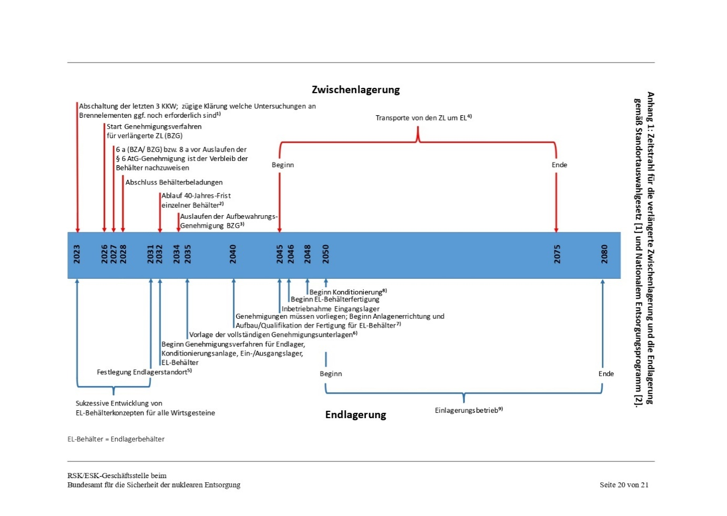

Source: Figure of (ESK 2023b)

Appendix 2: Cost Estimations of Nuclear Waste Disposal (Original)

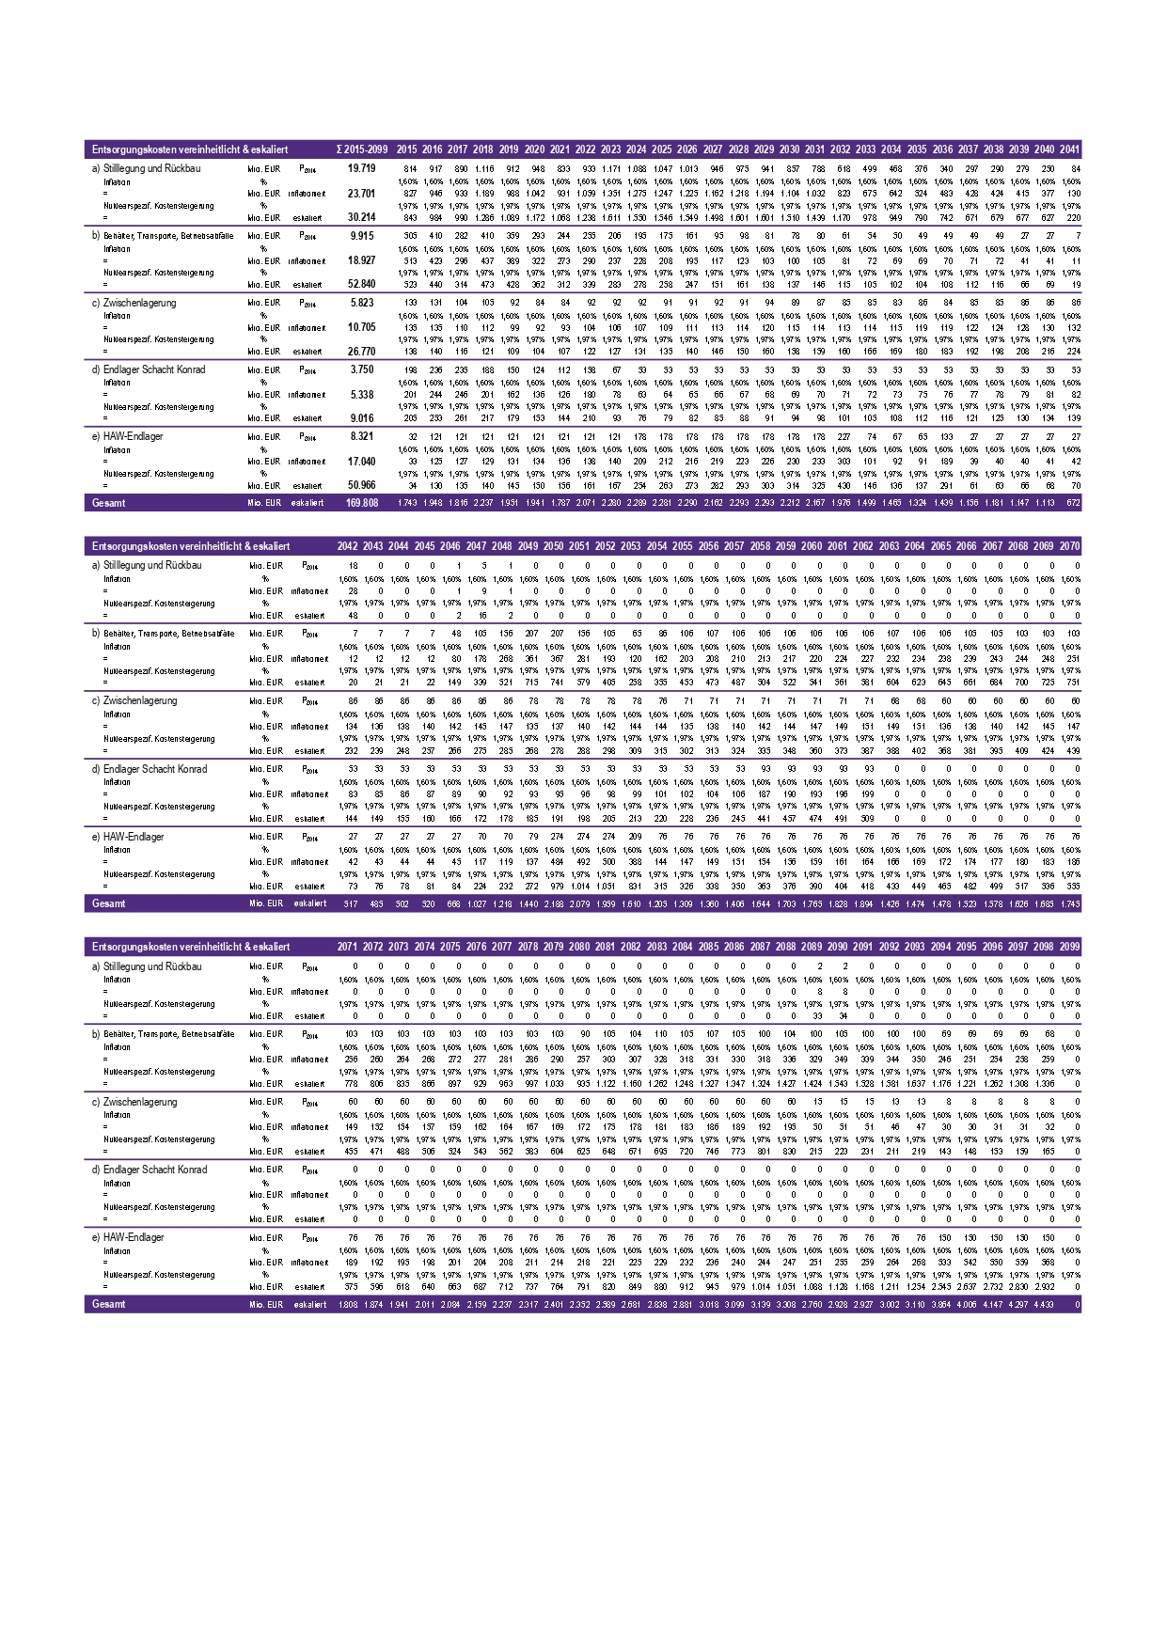

Source: (Warth & Klein Grant Thornton 2015)

Appendix 3: Detailed Planned Case Scenario Timeline

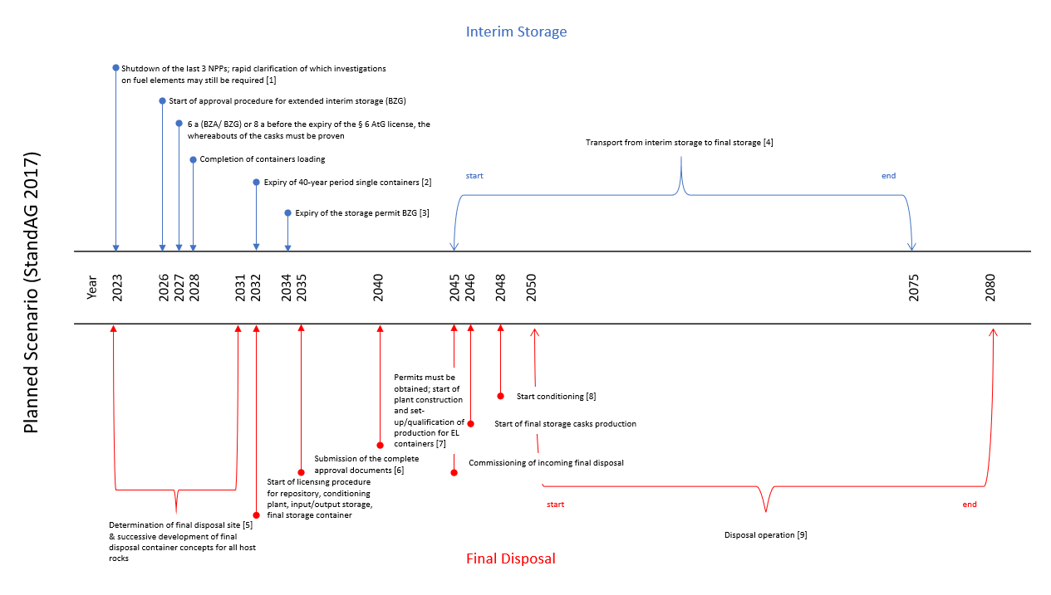

Source: Translated and slightly modified from (ESK 2023b; StandAG 2017)

Notes:

[1] Clarifying which information, e.g., on the aging behavior of containers and inventories, is still needed and how this can be obtained before the last transport and storage container (TSC) are sealed (BGZ, BASE, BAM).

[2] Concerns containers in the central interim storage facility (BZA), central interim storage facility north (ZLN), AVR Jülich, and in interim storage facilities of nuclear power plants (KKK, KWB, GKN, KKP).

[3] Remaining interim storage facilities follow until 2047; approvals for extended interim storage must be available when the previous approval expires.

[4] Approximately 1,100 TLB with LWR fuel elements, 137 containers with glass coquilles, and 479 with research reactor fuel elements; average transport frequency over 30 years: approx. 60 containers/year.

[5] With the determination of the final repository site, final disposal conditions, requirements for conditioning and final repository containers, and the concept for the input/output storage must also be established.

[6] Submission of the complete approval documents for the construction of the final repository, the conditioning plant, the input/output storage, and the final repository containers.

[7] Approvals for the construction of the final repository, the input/output storage, and the conditioning plant must be available; from 2046, production capacities for 1,870 final repository containers (i.e., approx. 60/year) or 5,940 final repository coquilles plus packaging (i.e., approx. 200/year) and transfer containers for 3,900 glass coquilles will be required over 30 years.

[8] Conditioning throughput of around 340 Mg SM/year and approx. 130 glass coquilles/year over 30 years. When the conditioning operation starts, final repository containers must be available.

[9] Depending on the final repository container design, an average of approx. 60 - 200 final repository containers with fuel elements and approx. One hundred thirty vitrified high-level waste crucibles per year must be disposed of over 30 years.

Appendix 4: Best Case Scenario Timeline

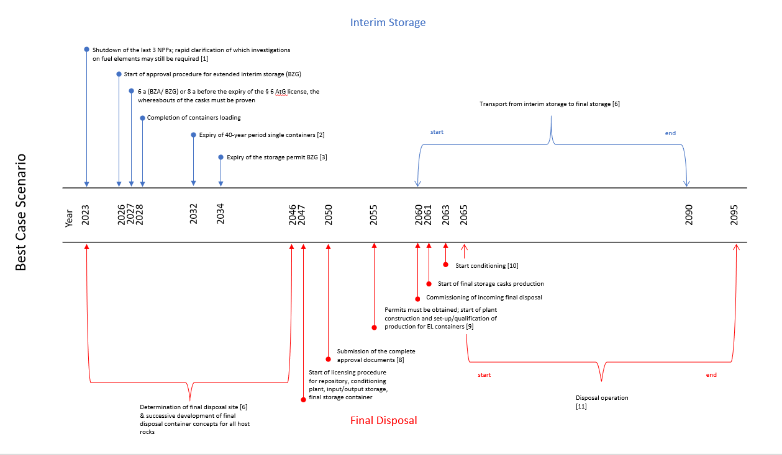

Appendix 5: Best Case Scenario Cost Projection

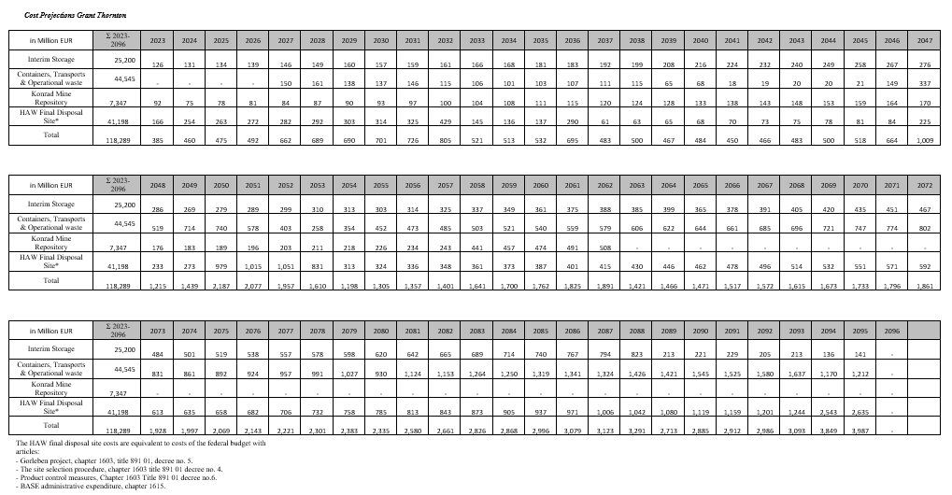

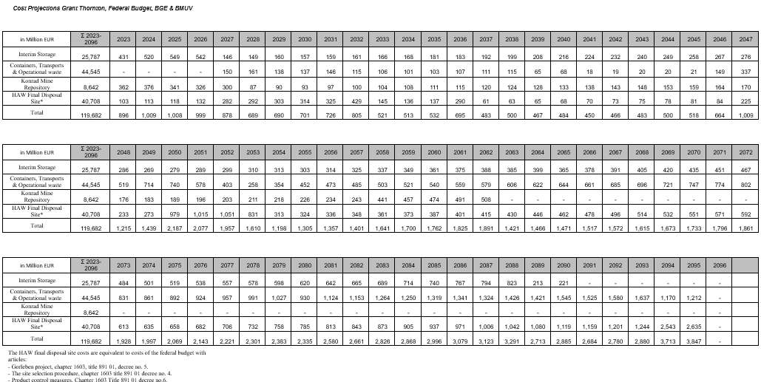

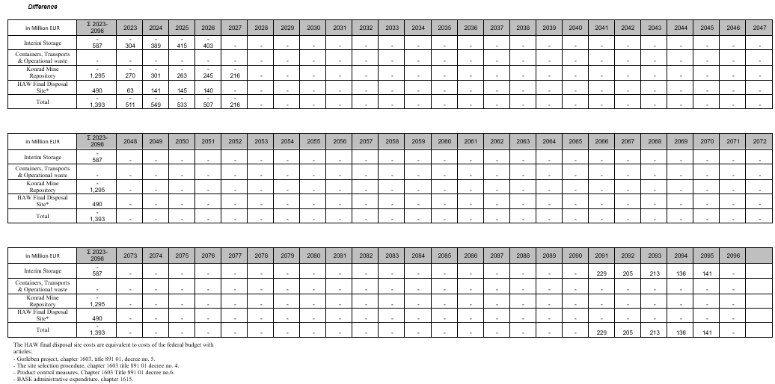

Appendix 6: Best Case Scenario Balance Simulation

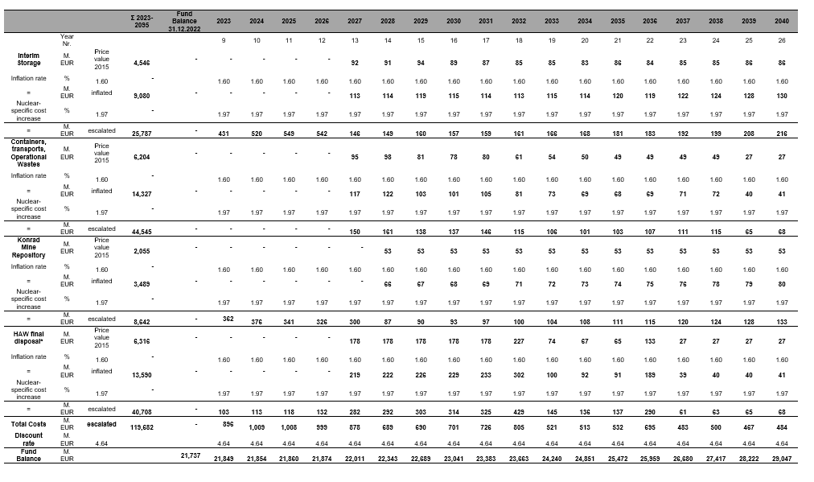

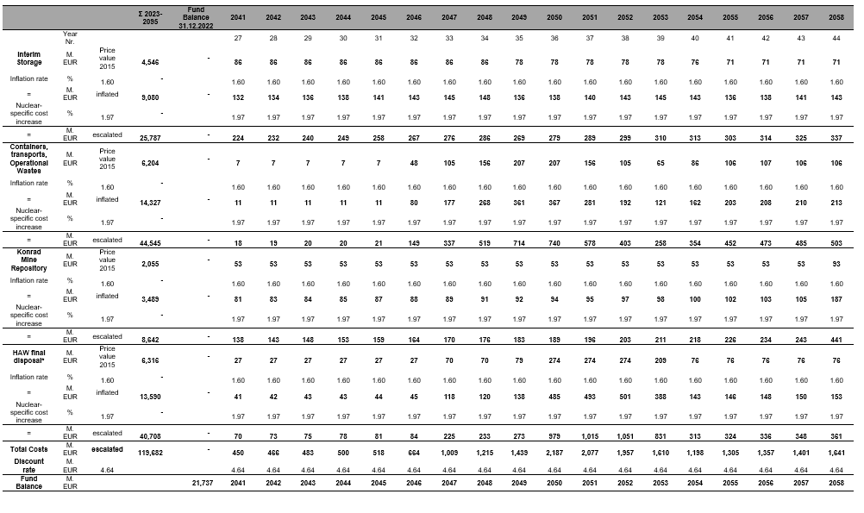

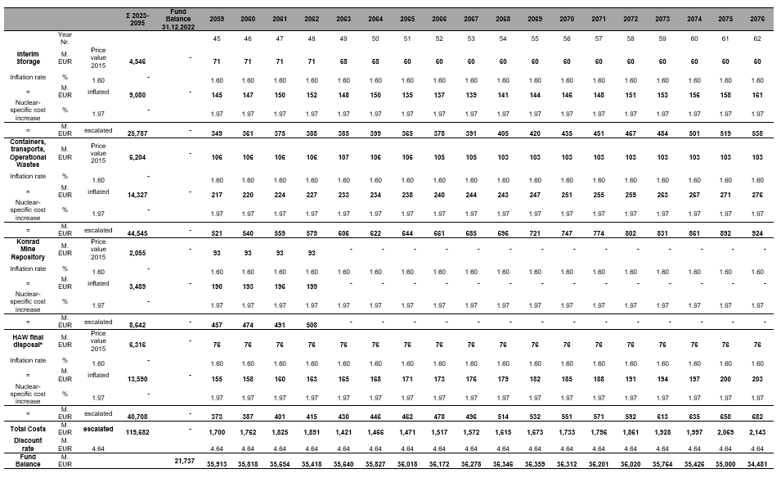

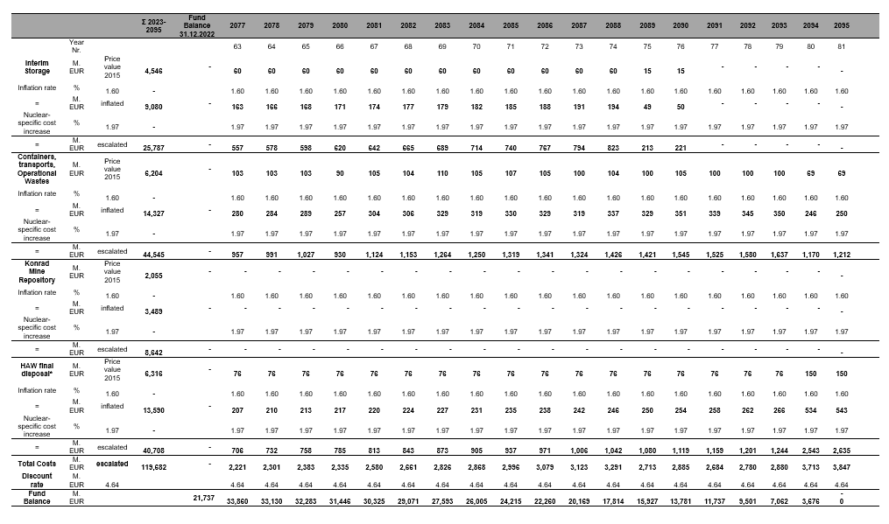

Appendix 7: Medium Case Scenario Timeline

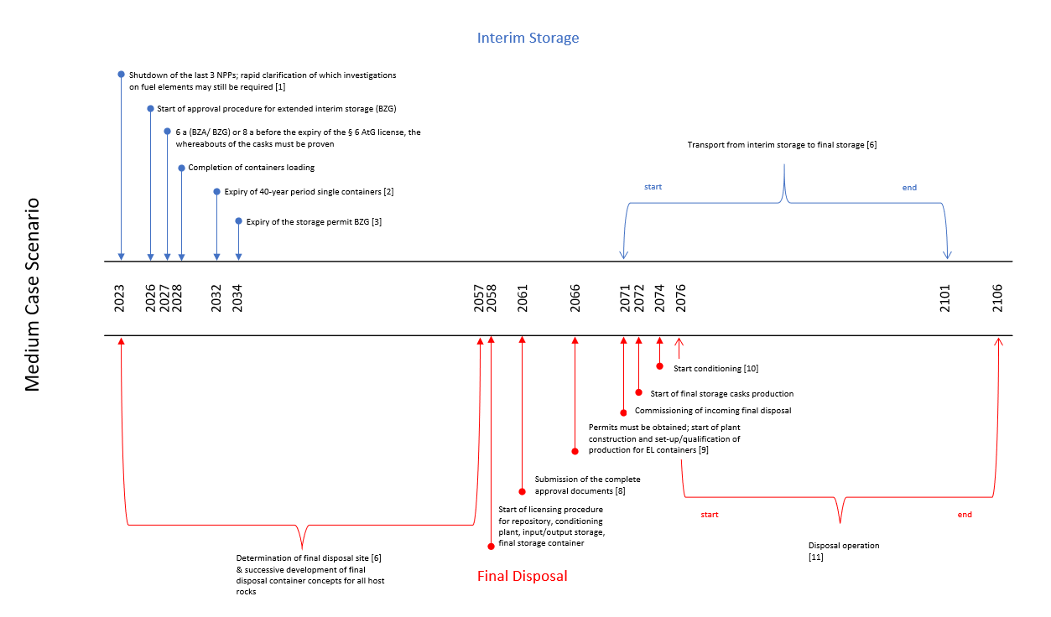

Appendix 8: Medium Case Scenario Cost Projections

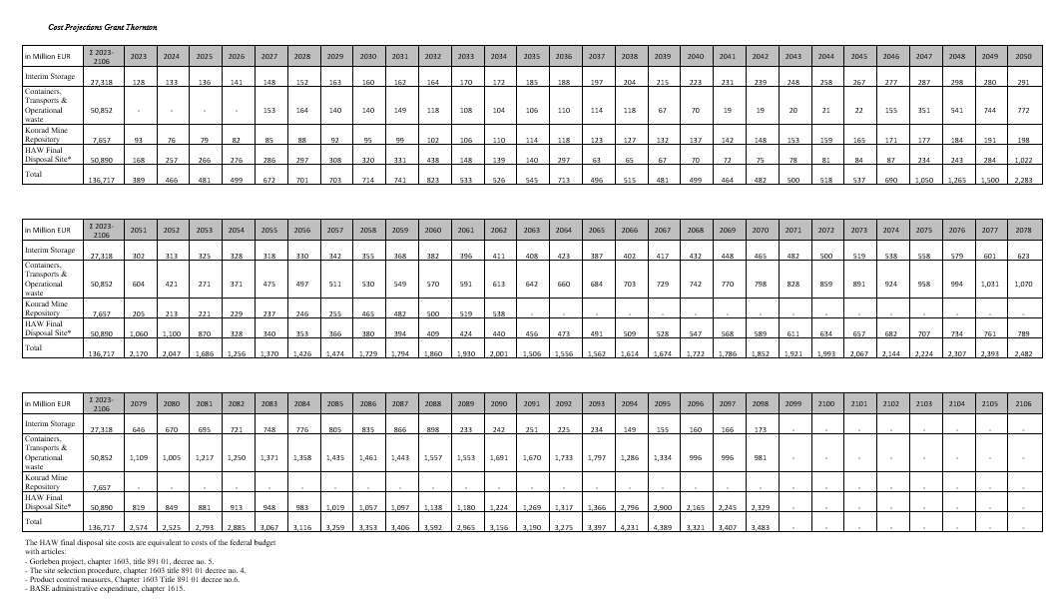

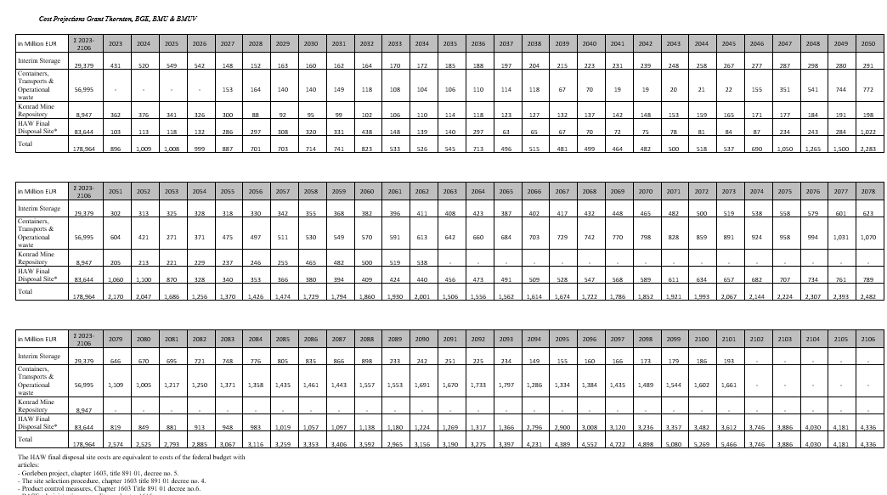

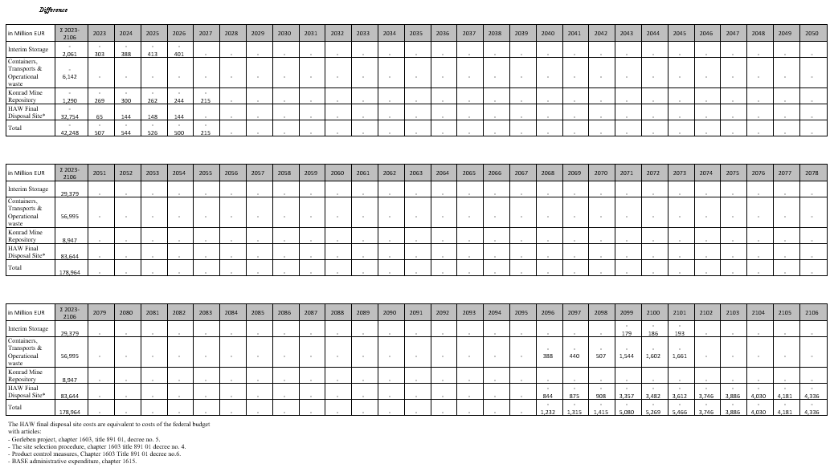

Appendix 9: Medium Case Scenario Fund Balance Simulation

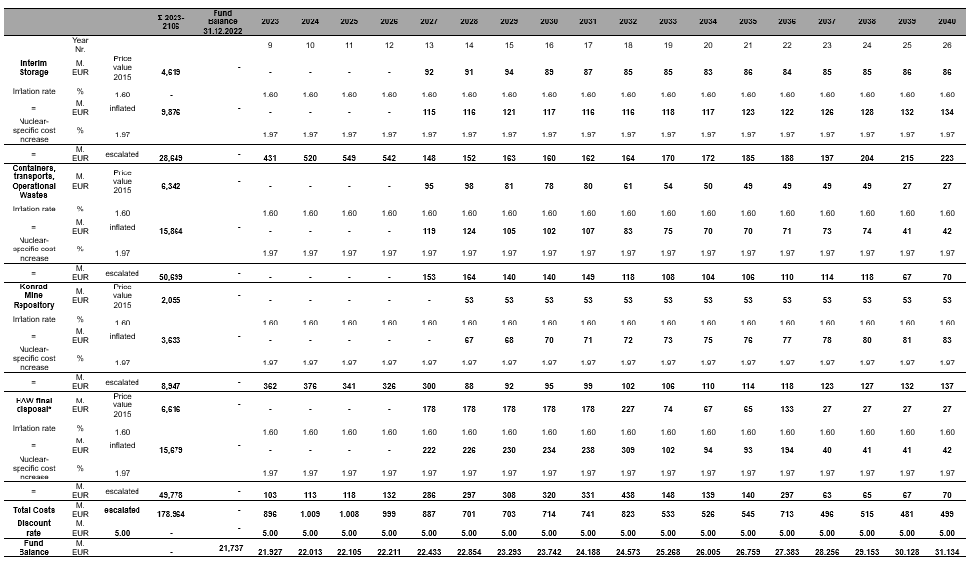

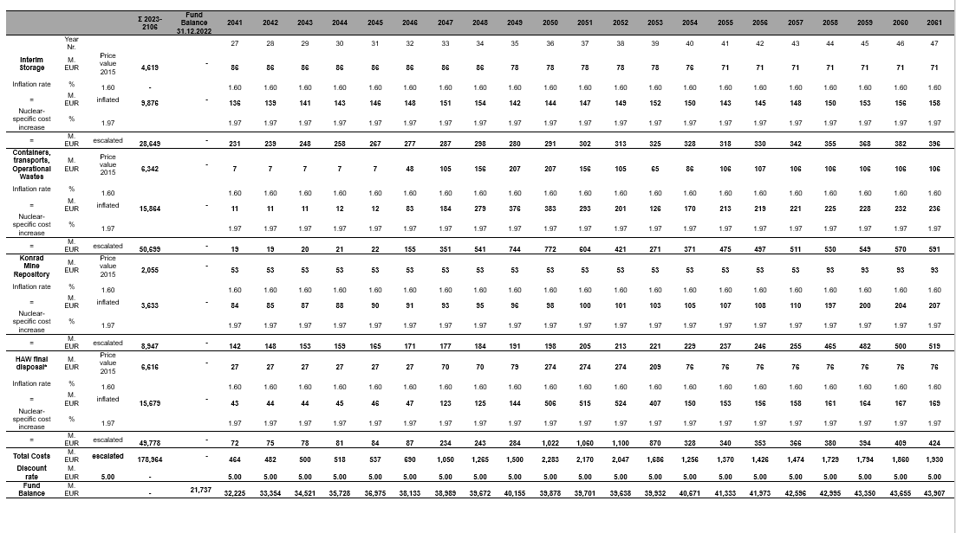

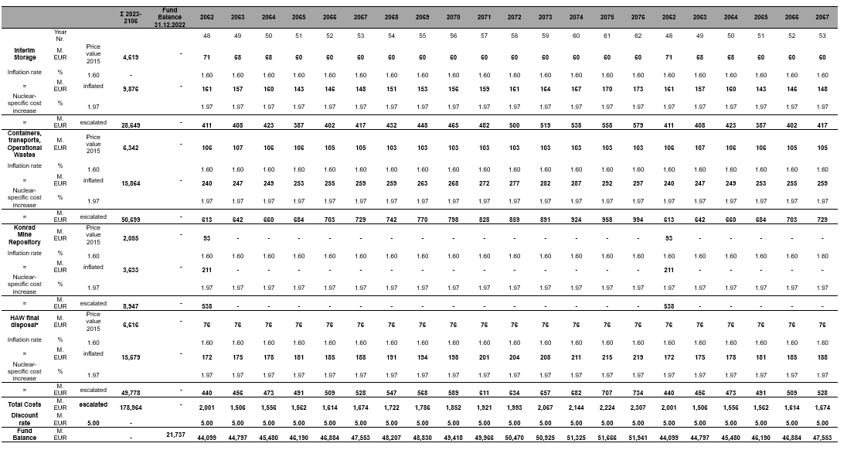

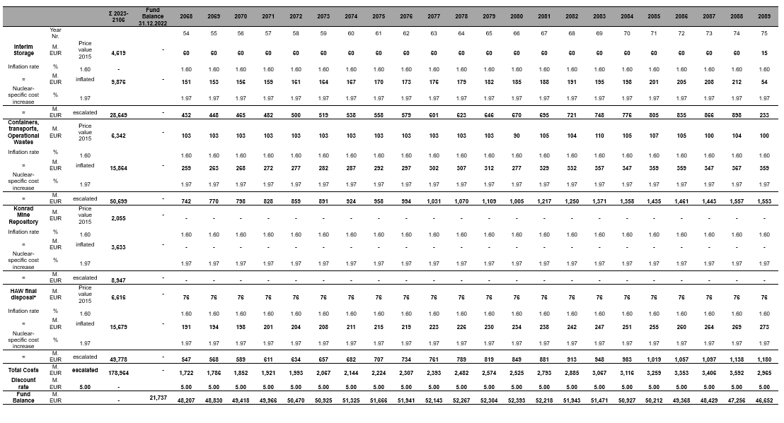

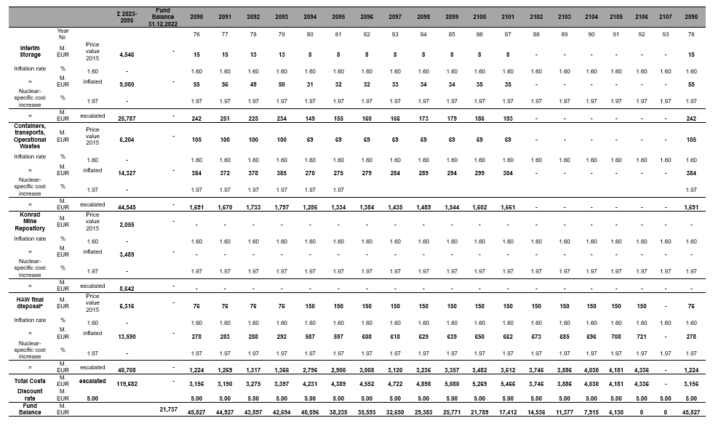

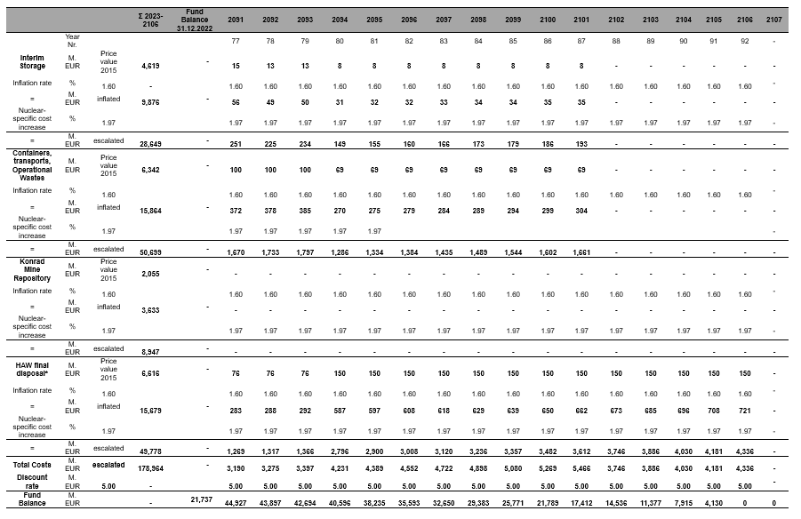

Appendix 10: Worst Case Scenario Timeline

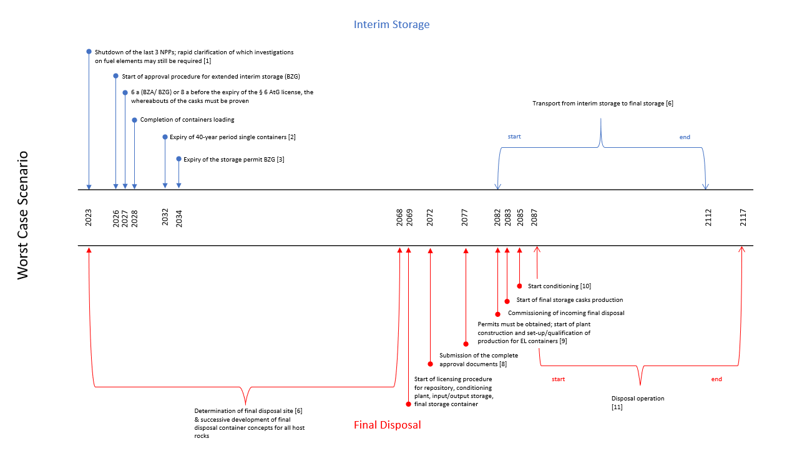

Appendix 11: Complete Ex-Ante Analysis

Note: Includes Cost Projections, Graphs, Fund Balance Simulations, and more.

Link: <https://tubcloud.tu-berlin.de/s/ir5iNGaEAqtzWGA>

Appendix 12: Complete Sensitivity Analysis

Link: <https://tubcloud.tu-berlin.de/s/eMJBfQY63cJATc4>

1. Source: Wealer and von Hirschhausen, "Nuclear Power as a System Good: Organizational Models for Production along the Value-Added Chain." (2020). Accessed August 20, 2023. <https://www.diw.de/documents/publikationen/73/diw_01.c.793995.de/dp1883.pdf>
2. Often in literature, LLW and ILW are classified into one category, referred to as Low- and intermediate-level radioactive waste (LILW).
3. Based on Act on Search and Selection of a Site for a final disposal site for High-Level Radioactive Waste of Site Selection Act of May 5, 2017 (Site Selection Act, StandAG) (German Federal Gazette p.1074), as last revised by Article 1 of the Act of December 7, 2020 (German Federal Gazette p. 2760).
4. The original cost projections to be found in the report “Gutachtliche Stellungnahme zur Bewertung der Rückstellungen im Kernenergiebereich” (Warth & Klein Grant Thornton 2015) in the first Appendix item. Alternativly,
5. The HAW final disposal site costs:

   In the federal budget, these are equivalent to:

   Gorleben project, chapter 1603, title 891 01, decree no. 5.

   The site selection procedure, chapter 1603 title 891 01 decree no. 4.

   Product control measures, Chapter 1603 Title 891 01 decree no.6.

   BASE administrative expenditure, chapter 1615.

   Containers, transports & operational waste, according to BGE, are parts of site selection procedures and product control measures.
6. Grant Thornton has estimated costs of €127 billion excluding the decommissioning of NPPs.
7. Exact value equals 4.09516302026521. See Appendix for more detailed information.
8. The exact timeframe is found in the Appendix.
9. The HLW final disposal site costs:

   In the federal budget, these are equivalent to:

   Gorleben project, chapter 1603, title 891 01, decree no. 5.

   The site selection procedure, chapter 1603 title 891 01 decree no. 4.

   Product control measures, Chapter 1603 Title 891 01 decree no.6.

   BASE administrative expenditure, chapter 1615.

   Containers, transports, and operational waste, according to BGE, are parts of site selection procedures and product control measures.
10. The HLW final disposal site costs:

    In the federal budget, these are equivalent to:

    Gorleben project, chapter 1603, title 891 01, decree no. 5.

    The site selection procedure, chapter 1603 title 891 01 decree no. 4.

    Product control measures, Chapter 1603 Title 891 01 decree no.6.

    BASE administrative expenditure, chapter 1615.

    Containers, transports, and operational waste, according to BGE, are parts of site selection procedures and product control measures.
11. Excluding decommissioning costs of NPPs, since this must be carried out and financed by the NPPs (VkENOG 2017).
12. Based on KENFO’s yearly ROI goal of 4.3% on the ***€21.7 billion*** current balance of KENFO.
13. The exact calculation and justification of this relatively low inflation target are found in (Warth & Klein Grant Thornton 2015), passage no. 38.
14. Also referred to as nuclear-specific discount rate. Calculations of (Warth & Klein Grant Thornton 2015). This assumption is associated with considerable uncertainties due to the long periods until after 2050 (KFK 2016).
15. As reported by KENFO’s chef manager, Anja Mikus, in an interview in November 2020 (Mikus 2020).
16. Further detailed information regarding the timeline of execution of main projects and milestones is to be found in Appendix 4,5 with the title Best Case Scenario Cost Projection and Best Case Scenario Timeline.
17. To be found in the first Appendix item of “Expert Opinion on the Valuation of Provisions in the Nuclear Energy Sector” (Warth & Klein Grant Thornton 2015). Alternatively, see Appendix 2.
18. The HAW final disposal site costs are equivalent to costs of the federal budget with articles:

    Gorleben project, chapter 1603, title 891 01, decree no. 5.

    The site selection procedure, chapter 1603 title 891 01 decree no. 4.

    Product control measures, Chapter 1603 Title 891 01 decree no.6.

    BASE administrative expenditure, chapter 1615.

    Containers, transports & operational waste, according to BGE, are part of site selection procedures and product control measures.
19. Without the decommissioning and dismantling costs of NPPs (VkENOG 2017)
20. A surplus of €952.000.000 for the years 2091-2096 from the perspective of the German federal government.
21. Values of costs projections in billion € rounded up to two decimal values. The exact costs are to be found in the Appendix. The timeline is defined as follows: t0 = 2022, t1 = 2023, …, tT = 2096.
22. The value to be solved for.
23. The exact amount of the foundation’s assets on 31.12.2022 is € 21,736,939,067.39. According to the annual report 2022 (KENFO 2023c).
24. The pseudo-code describes the functionality of the approach, while in reality, the actual code was implemented using the programming language “Java.”
25. Exact value of required target ROI = 4.639146503178681%
26. The exact adjustments of the ex-ante analysis are found in the Appendix for the table “Medium Case Scenario Cost Projections”.
27. Hereby, we intentionally excluded the years 2022 and 2023 from the calculation, arguing that the economic effects of the pandemic and war in Ukraine on the German inflation rate are “one-time” from the perspective of the medium case scenario. The assumption here is that the market inflation rate will indeed, on average, converge towards the target inflation rate declared by the German central bank.
28. Calculations of (Warth & Klein Grant Thornton 2015). This assumption is associated with considerable uncertainties due to the long periods until after 2050 (KFK 2016).
29. As reported by KENFO’s chef manager Anja Mikus in an interview in November 2020.
30. Further detailed information regarding the timeline of execution of main projects and milestones is to be found in the Appendix with the title “Medium Case Scenario Cost Projections” and “Medium Case Scenario Timelines.”
31. Values of costs projections in billion € rounded up to two decimal values. The exact costs are to be found in the Appendix. The timeline is defined as follows: t0 = 2022, t1 = 2023, …, tT = 2096.
32. The value to be solved for.
33. The exact amount of the foundation’s assets on 31.12.2022 is € 21,736,939,067.39. According to the annual report 2022 (KENFO 2023c).
34. The exact return value of the function equals to 4.9967239362385225%
35. The exact adjustments of the ex-ante analysis are found in Appendix 8.
36. Hereby, we intentionally excluded the years 2022 and 2023 from the calculation, arguing that the economic effects of the pandemic and war in Ukraine on the German inflation rate are “one-time” from the perspective of the medium case scenario. The assumption here is that the market inflation rate will indeed, on average, converge towards the target inflation rate declared by the German central bank.
37. Calculations of (Warth & Klein Grant Thornton 2015). This assumption is associated with considerable uncertainties due to the long periods until after 2050 (KFK 2016).
38. As reported by KENFO’s chef manager Anja Mikus in an interview in November 2020.
39. To be found in the first Appendix item of “Expert Opinion on the Valuation of Provisions in the Nuclear Energy Sector” (Warth & Klein Grant Thornton 2015).
40. Values of costs projections in billion € rounded up to two decimal values. The exact costs are to be found in the Appendix. The timeline is defined as follows: t0 = 2022, t1 = 2023, …, tT = 2096.
41. The value to be solved for.
42. As stated by KENFO in subsection 4.3.3, 31.12.2022 KENFO’s total assets of was €21.7 billion (KENFO ARD 2023). The exact amount of the foundation’s assets on 31.12.2022 is € 21,736,939,067.39. According to the annual report 2022 (KENFO 2023).
43. The exact return value of the function equals to 5.166619605849176%
44. Exact value equals €23,577,213.00
45. Simulation found in the Excel file in Appendix 8.
46. Exact value of ROI equals 3.75153595068608%. The fund’s balance at the end of 2080 will be €0.
47. Justifications of the assumptions are discussed in the corresponding subsection in section ‎4.
48. The exact cost projections for each year of the corresponding scenario for each cost category are found in the Appendix.
49. Difference of 4.64% - 4.10% results of 0.54%. The calculations were applied to the exact values of the used method in ‎3.2.
50. This outcome incorporates the impact of compound interest over extended timeframes.
51. The exact simulations are found in Appendix 8.
52. The reason for comparing the timeframe of 2017-2022 and not 2015-2022 is that for 2015-2016, there were no exact reports from BMUV or the federal government on the interim storage actual costs.
53. Combination of five inflation rates with five cost increases, with three timelines scenarios: 5 × 5 × 3 = 75.
54. True for year 2023
55. Determination of site in 2046, inflation rate 1.60%, and nuclear-specific discount rate 1.97%.